All About Mexico

Interesting facts you have found out about Mexico (use additional sheet):

Surrounding oceans and seas:

Mexican festivals:

Climate:

Capital city:

Population:  
  
  
Size (square miles):

Colour Mexico

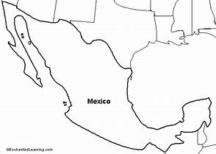

Mexican food:

Bordering countries: