Science **Animals Including Humans** Watch <https://www.bbc.co.uk/bitesize/clips/ztfnvcw>

Complete the skeleton labelling activity.  
Make and label a human skeleton. Use what you can find in your garden and house.  
  
**Challenge:** Label the bones using their scientific names. How many bones are in each hand and foot?  
How many bones are in the human body?

**English** Watch the powerpoint about Mexico.  
<https://www.twinkl.co.uk/resource/us2-g-12-all-about-mexico-powerpoint>

Research about Mexico and complete the factsheet ‘All about Mexico’.

Enjoy going on a reading adventure every day.

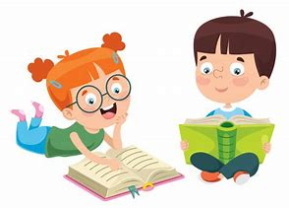

**Swifts Home Learning-Week 1**

**Swifts growth mindset “I can’t do it yeti!”**

**Maths** Daily Maths Whizz (30 mins).

 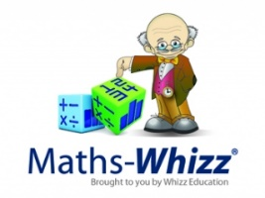  
<https://www.timestables.co.uk/speed-test/>

**Addition and subtraction.**

Use a die or a number generator to generate your own numbers. Use these numbers to create addition and subtraction sums. You could make 1 digit, 2-digit, 3-digit or 4-digit numbers. What can you use to support your counting?

You could do your work on a number line, use objects from around the house to help or use column addition/subtraction. Remember when we subtract you need to put the biggest number first.

+ 432 - 56

123 12

Can you write word problems for others to solve?

Extension questions on separate file.

**Art Watch the Frida Kahlo powerpoint.** Find out about and write ten facts about the famous Mexican artist Frida Kahlo. Choose a Frida Kahlo self-portrait picture. Stick it on a piece of paper. Write some adjectives around the picture to describe it. Write what you like and dislike about your chosen Frida Kahlo self-portrait. Think about the colours and how it makes you feel. Use your senses.   
**Challenge:** Recreate your own copy of your favourite Frida Kahlo portrait.

**Geography**Watch an introduction to Mexico.

**<https://www.bbc.co.uk/programmes/p0114db0>**

Draw and colour the Mexican flag.

Label the map of Mexico.

<https://www.twinkl.co.uk/resource/us2-g-11-differentiated-map-of-mexico-differentiated-labeling-activity-sheets>

**French**

Play a game of bingo using the French numbers 0 – 20.

**Music** 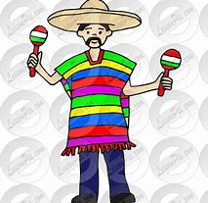

Listen to some Mexican music at

<https://www.youtube.com/watch?v=RhKj1lqg_5o>

Do you like it? How does it make you feel? Can you identify any of the instruments being used?

**P.E.**

Have a go at the Mexican Hat Dance. <https://www.youtube.com/watch?v=3JedVIAeBm0> (watch till 2:01) You could add your own movements.

**Hola Mexico!**

