**Maths**

Keep on counting!! On and back in from any number. Also in 2s/3s/5s and 10s. You could use the correct coins to help practise the 2s/5s/10s counting

* Daily Maths Whizz (30 minutes)
* **Please see Hamilton free home learning packs for Y1 and Y2**

<https://www.hamilton-trust.org.uk/blog/learning-home-packs/>

* Also NRICH have some free and fantastic games and activities suitable for working from home

https://nrich.maths.org

**English**

Make a collection of as many fiction and non-fiction books that feature jungle animals or a rainforest setting for you to read and enjoy.

Write a book review about one of the books. If it’s a fiction book include characters, setting, plot, likes, dislikes. If it’s non- fiction, review the layout (what did you like/dislike) and features such as contents page/index. Were they helpful? What did you find out?

**Skylark’s**

**Home Learning ☺  
Week 1**

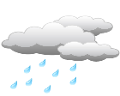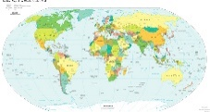

**P.E.** Use Joe Wicks live PE session for a stronger work out

<https://www.youtube.com/channel/UCAxW1XT0iEJo0TYlRfn6rYQ>

OR Cosmic Yoga for a gentler stretch and active stories

<https://www.youtube.com/user/CosmicKidsYoga>

**Science**

Use your senses and go on an imaginary walk through the rainforest- can you name the senses?

Draw a picture and write down what you sense!

*\*See example sheet to print or copy*

**Music ♪**

Practice making softer/louder sounds with your hands –by rubbing/clicking/clapping etc

Watch the ‘Perpetuum Jazzile’ Choir create a rainstorm with hands

<https://www.youtube.com/watch?v=BC8re5HvOGI>

Have a go at creating your own hand rainstorm with the people you live with.

Roaming the Rainforest

Take a virtual tour of the Amazon Rainforest

<https://www.youtube.com/watch?v=JEsV5rqbVNQ>

**Geography**

ID & locate rainforests/features /countries etc on a world map.

Discuss weather patterns & the equator.

**Art**

Find out about snakes of the rainforests. Make your own spiral snake from a paper plate or circle of card. Decorate on both sides for full effect, then cut.

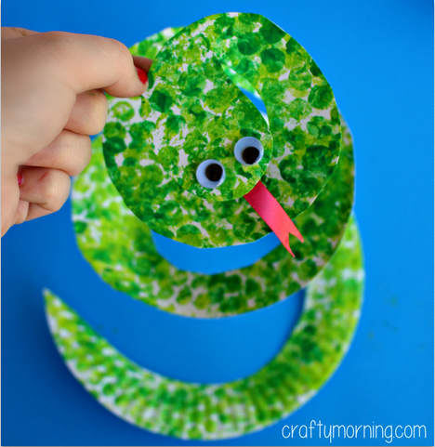

**Computing**

Have a go on the ‘Scratch’ link on the school website.