**Maths**

Set up a home shop, price items up to 30p or 99p. Can you total amounts? Can you give change?

* Daily Maths Whizz (30 minutes)
* **Please see Hamilton free home learning packs for Y1 and Y2**

<https://www.hamilton-trust.org.uk/blog/learning-home-packs/>

* Also NRICH have some free and fantastic games and activities suitable for working from home

https://nrich.maths.org

**Skylark’s**

**Home Learning ☺  
Week 2**

**English**

Read and discuss Monkey Puzzle by Julia Donaldson

<https://www.youtube.com/watch?v=do93X-agQDo>

Can you write your own animal riddle? Write as many clues as you can and finish the poem with the question What am I?

Roaming the Rainforest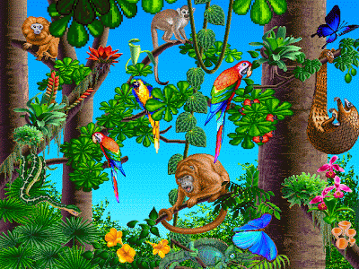

Rainforests by National Geographic

<https://www.youtube.com/watch?v=3vijLre760w>

**P.E.**

Use Joe Wicks live PE session for a stronger work out

<https://www.youtube.com/channel/UCAxW1XT0iEJo0TYlRfn6rYQ>

OR Cosmic Yoga for a gentler stretch and active stories

<https://www.youtube.com/user/CosmicKidsYoga>

**Science**

Identify and name a variety of animals.

Use animal toys or pictures to sort them into different groups according to their features. For example, fur, four legs, claws or flippers

**Geography**

Look at and discuss the maps of the world. *\* see attached map sheet to print*

Colour and complete the key for the continents, oceans and rainforests of the world.

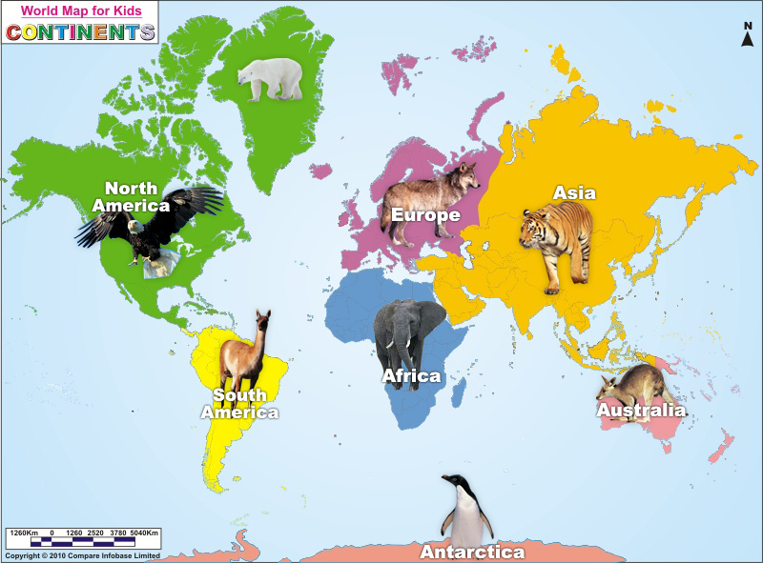

**Art**

Practice drawing some animals and plants of the rainforest.

Use sketching, drawing or painting skills and explore different types of pens/pencils/chalk/charcoal or paint

Think about line, colour, texture and shade.

Use any animal book/picture or toy to inspire you.

**Music**

Make some musical instruments like a shaker or a rain stick. Explore making loud/soft and long/short sounds.

**Computing**

Use the scratch link on the school website.