Viking Weapons, Armour and Tactics
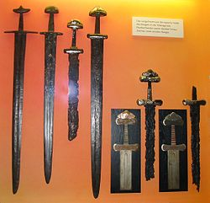
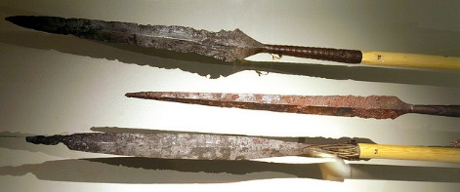
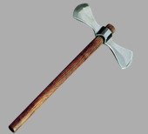
The three weapons the Vikings used most were spears, axes and swords. The spear was the most common weapon used by the Vikings. Spears were made from an iron blade at the end of a long wooden shaft and were used for thrusting and throwing. There are accounts of the best spearmen being able to throw two spears at once, using both hands, and being able to catch spears in mid-air to throw them back at the enemy. The double-handed broad axe is the most famous weapon used by the Vikings. A long handle meant the axe reached further and allowed the warrior to use both hands to wield the heavy blade. The problem with using both hands, however, meant that the warrior could not hold a shield at the same time. Swords were the most expensive of the three weapons to make and were often worn as a symbol of the warrior’s wealth and power. As well as being a useful tool for killing one’s enemies, swords were often works of art too. Viking craftsmen created richly decorated hilts and beautifully forged blades with welded patterns and inscriptions in the metal. Many swords were given names. Weapons were very important to the Vikings. It was the law for all Viking men to carry weapons, so Vikings were always armed and very dangerous.

To defend themselves against their enemies, Vikings carried round wooden shields. In battle, Viking armies would line up with their shields overlapping, creating a shield-wall. Rich Vikings would also wear helmets and chainmail tunics. Chainmail was made by linking many circles of iron together to form a metal cloth. This took a long time, which is why only the wealthy could afford it. Those who could not afford chainmail may have used reindeer hide to protect themselves from sword blows and arrows. Reindeer hide may have actually been even more effective than chainmail.
All evidence suggests that the Viking warriors were fearsome fighters. The warriors with the fiercest reputation were the ‘berserks’ (which is where the English word ‘berserk’ to mean wildly angry comes from). These warriors were said work themselves into such a fury before battle that they would believe they were indestructible and had superhuman powers.
