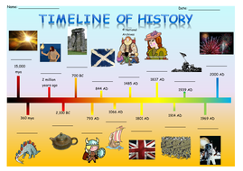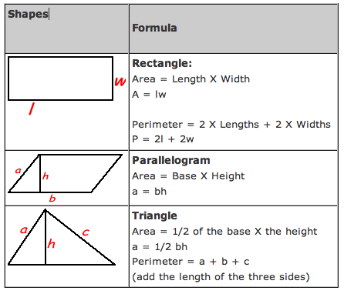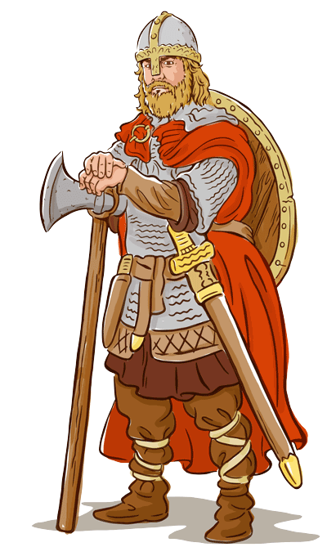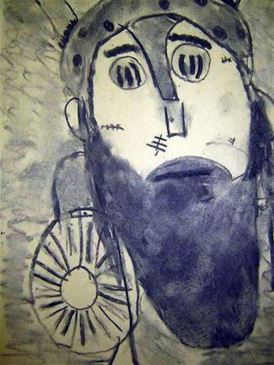

RE: Hinduism

Have a go at Bollywood Dancing!

How does dancing make you feel?

<https://www.youtube.com/watch?v=3NomZw-KD34>

Science:

Write definitions for the 3 states of Matter- solids, liquids and gases.

Then draw and label some examples of each.

<https://www.theschoolrun.com/what-are-states-of-matter>

<https://www.bbc.co.uk/bitesize/topics/zkgg87h/articles/zsgwwxs>

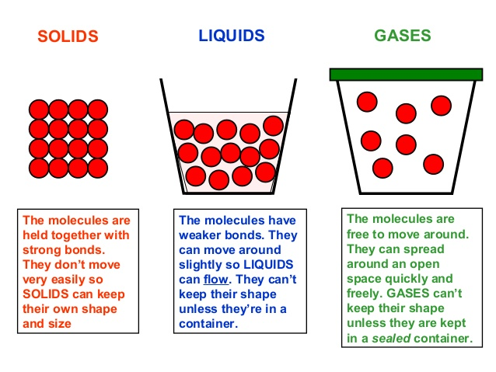

The Vikings

Week I

History Research:

How do we know about the Saxons/ Vikings?

Think about written evidence, archaeology, place names, sagas.

<http://www.bbc.co.uk/history/ancient/vikings/evidence_01.shtml>

Draw an illustrated time-line, showing when the Vikings invaded. How long did the Viking age last? Add any other information of periods and events that you know about.

English: Write a letter of complaint to a shop/manufacturer about a present you have received (real or imaginary) which is faulty.

See Help sheet for vocabulary and phrases.

Art: Can you Draw a portrait (head and shoulders) of a Viking?

Think carefully about where to place should be half -way down the features (remember eyes and ears the head.)

Make him as fearsome as you can!

Remember:

The perimeter is the length all around the edge of the shape and the Area is the length X the width.

Maths:

Triangles and Circles:

Find the perimeter and area of rectangular objects in your home and garden.

Pentagon and Squares:

Draw some composite shapes and find the a and p. Can you add a triangle?