- The number in the box above two other boxes is the sum of the two numbers below it. Work out the missing numbers.
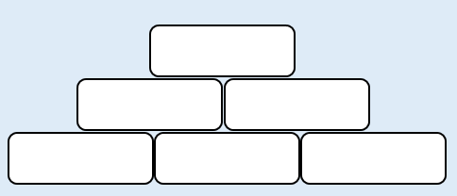
22
19
27
68
- The number in the box above two other boxes is the sum of the two numbers below it. Work out the missing numbers.
16
10
39
3. Write four number sentences using the information in this bar model.

67
156
89
Extension
- A school has 723 exercise books. 4,256 more were ordered for the year. If throughout the year 3,571 were used, how many exercise books will be available for the next school year?

- A museum has 12,657 visitors during June. Throughout July, 9,246 visitors entered the museum. In June, 3,245 of the visitors were children. During July, 825 of the visitors were children. How many adults visited the museum during June and July?

