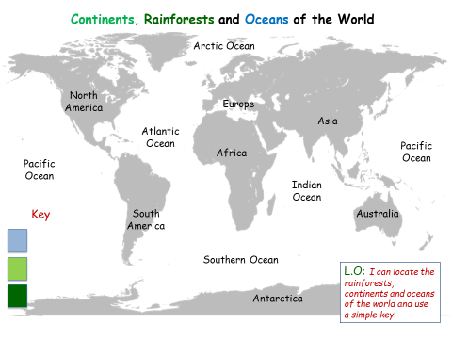

**Rainforest**

**Year 1 – Home learning Week 2**

**Land**

**Oceans**