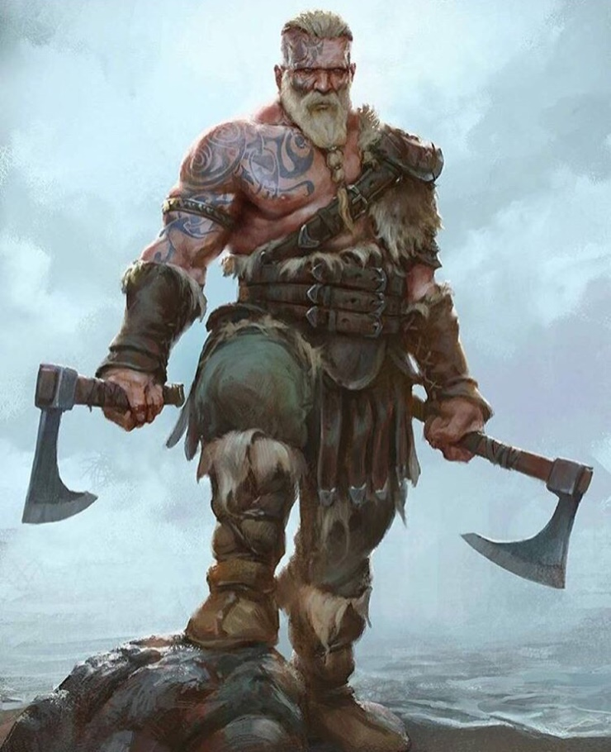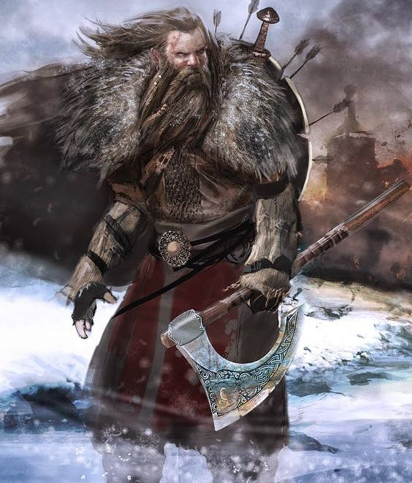

Characteristics: | feared/ fearless | Scandinavian | Clothes:
adventurous | ferocious | seafaring | animal-skins
aggressive | fierce | shield | belted
barbarian | grim | strong | brooch
bearded | helmet | sturdy | cloak
blond | heroic | sword | fur-lined boots
blood-thirsty | hirsute | tattooed | knee- length tunic
brutal | invader | triumphant | layers
conquer | matted hair | valiant | leather
cruel | Norse | victim | loose-fitting
Danish | pagan | violent | knife
destroy /destruction | pillage raid | warlike | trousers
disgruntled | ruthless | weary | woollen
enraged | savage | zealous | woven

