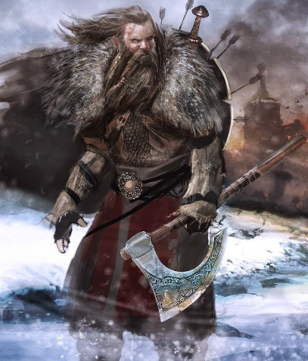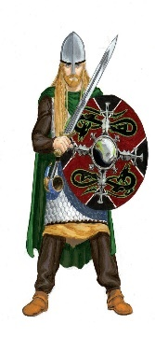 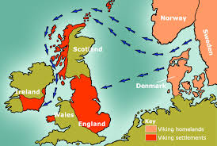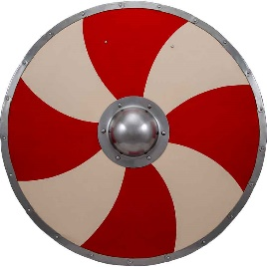

Maths

Y5 Factors and Multiples

Y6 Area, Volume and Scaling

Go to:

<https://www.hamilton-trust.org.uk/blog/learning-home-packs/> (Week 3)

There are activities for each day for Year 5 and Y6.

Try to do an hour each day, but don’t worry if you can’t complete it all- there is a lot there.

The Vikings

Week 2

RE: Research Hindu Worship.

Can you answer these questions?

How do Hindus worship?

Who do they worship?

Why do they worship?

Where and when do they worship?

What do they use to worship?

Are there special times of worship?

<https://www.bbc.co.uk/bitesize/clips/zh2hyrd>

Shiny

Waterproof

Flexible

Rough

Soft

Durable

Science

Choose different objects and think about the different properties of the materials. Fill in the table.

Translucent

English

Write a character description of a Viking.

Think about his appearance- facial and bodily features and clothes, and his character.

Use powerful adjectives and adverbs (use word-bank to help you.) Try to make tour work flow, by using cohesive devices such as connectives, prepositional phrases, pronouns.

Humanities

Research to find the answers to these questions

Where Did the Vikings come from? Where did they invade and settle? Why? When? Why were they so successful? Can you draw a map to show the routes they took?

Art/DT

Find out about Viking shields and weapons.

Design your own shield (see template.) Perhaps you would like to have a go at making your own?

<https://primaryfacts.com/5606/viking-shields-facts-and-information/>

<https://harreira.com/viking/what-is-a-viking-shield-designs-and-meanings/>