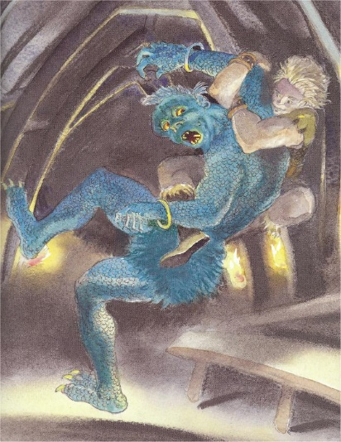
BEOWULF
Main Characters
- Beowulf- the hero

- Hrothgar- King of the Danes

- Grendel- a monster who preys on Hrothgar’s men

- Grendel’s mother- a swamp-hag who tries to avenge her son’s murder

- A Dragon -who guards a hoard of treasure

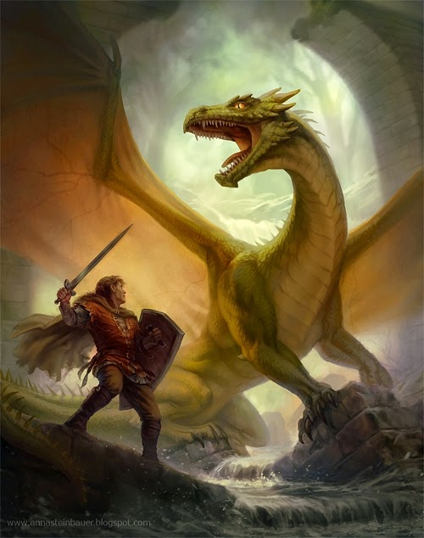
- Wiglaf – a brave and loyal warrior, who helps Beowulf fight the dragon, and becomes king.

A precis of the story (Narrative Poem)
King Hrothgar of Denmark enjoys a prosperous and successful reign.
He builds a great mead-hall, called Heorot, where his warriors can gather to eat, drink and listen to stories and celebrate the time of plenty.
But the jubilant noise from Heorot angers Grendel, a horrible demon who lives in the swamplands of Hrothgar’s kingdom. Grendel terrorises the Danes, killing many of Hrothgar’s men every night. The Danes suffer many years of fear, danger, and death at the hands of Grendel. Eventually, however, a young Geatish warrior named Beowulf hears of Hrothgar’s plight. Inspired by the challenge, Beowulf sails to Denmark with a small company of men, determined to defeat Grendel.
Hrothgar, who had once done a great favour for Beowulf’s father Ecgtheow, accepts Beowulf’s offer to fight Grendel and holds a feast in the hero’s honour. During the feast, an envious Dane named Unferth taunts Beowulf and accuses him of being unworthy of his reputation. Beowulf responds with a boastful description of some of his past accomplishments. His confidence cheers the Danish warriors, and the feast lasts merrily into the night. At last, however, Grendel arrives. Beowulf fights him unarmed, proving himself stronger than the demon, who is terrified. As Grendel struggles to escape, Beowulf tears the monster’s arm off. Mortally wounded, Grendel slinks back into the swamp to die. The severed arm is hung high in the mead-hall as a trophy of victory.
Overjoyed, Hrothgar showers Beowulf with gifts and treasure at a feast in his honour. Songs are sung in praise of Beowulf, and the celebration lasts late into the night. But another threat is approaching. Grendel’s mother, a swamp-hag who lives in a desolate lake, comes to Heorot seeking revenge for her son’s death.
She murders Aeschere, one of Hrothgar’s most trusted advisers, before slinking away. To avenge the death, Beowulf travels to the murky swamp, dives into the water and fights Grendel’s mother in her underwater lair. He kills her with a sword made for a giant, then, finding Grendel’s corpse, decapitates it and brings the head as a prize to Hrothgar.
The Danes are again overjoyed, and Beowulf’s fame spreads across the kingdom. Beowulf returns to Geatland, where he and his men are reunited with their king and queen, Hygelac and Hygd.
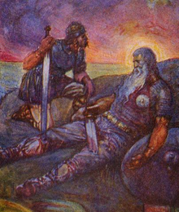
In time, Hygelac is killed in a war and Beowulf becomes king of the Geats. He rules wisely for fifty years, bringing prosperity to Geatland. When Beowulf is an old man, however, a thief disturbs a mound, where a great dragon lies guarding a hoard of treasure. Enraged, the dragon emerges and begins unleashing fiery destruction upon the Geats. Beowulf goes to fight the dragon. with the aid of a brave and loyal young warrior named Wiglaf. Beowulf succeeds in killing the beast, but the dragon bites Beowulf in the neck, but is mortally wounded. The Geats fear that their enemies will attack them now that Beowulf is dead. According to Beowulf’s wishes, they burn his body on a huge funeral pyre and then bury him with a mass of treasure in a barrow overlooking the sea. Wiglaf becomes the next King.

