Maths

Draw a beanstalk with 20 leaves on it. Can you label the leaves on your beanstalk with the numbers 1-20 in sequence?

Practise counting in twos in sequence on your numbered beanstalk. 2, 4, 6, 8… forwards and backwards.

Use your numbered beanstalk to play racing game ‘Jack versus the Giant’. Take it in turns to roll a dice. Race down the beanstalk from 20. Who can reach the bottom first Jack or the Giant?

Expressive Arts and Design

Can you make a beanstalk that it taller than you? You could paint one or you could use recycled materials.

Sing one (or both) of the Jack and the Beanstalk songs on Tapestry. You could film yourself singing it and upload it onto Tapestry.

**Living and Growing – Jack and the Beanstalk**

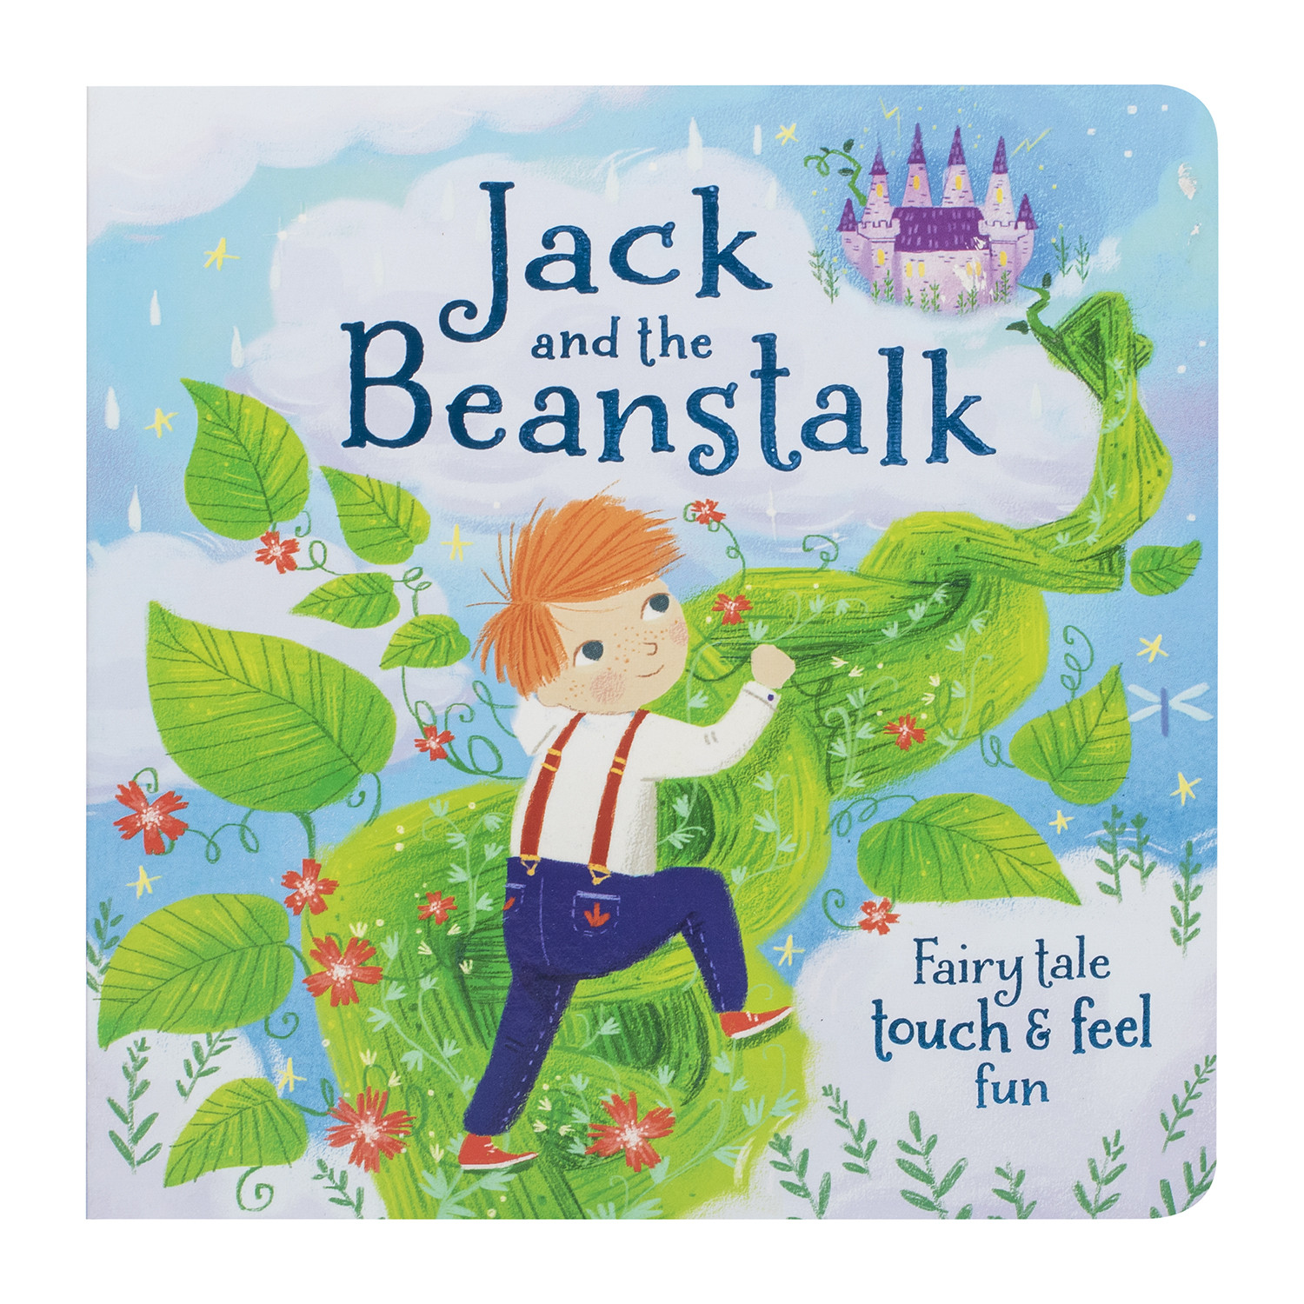

Understanding the World

Watch this bean growth time lapse video on Twinkl <https://www.twinkl.co.uk/resource/t-t-18903-bean-timelapse-video-powerpoint>

Plant some different types of beans e.g. baked beans, jelly beans, broad bean seeds etc. Which ones do you think will grow? Why? What will your beans need to grow?

Literacy

Read a copy of Jack and the Beanstalk. If you don’t have a copy at home, there are plenty of versions on YouTube.

Write a magic spell for the magic beans.

Create a wanted poster for the Giant

Read Jasper’s Beanstalk. This is available on YouTube if you don’t have a copy. Can you talk about what ‘Jack and the Beanstalk’ and ‘Jasper’s Beanstalk’ have in common?

Personal, Social and Emotional Development

Talk about the Giant. Why did he chase Jack? How would you feel if someone took your belongings? What could the Giant have done instead?

Physical Development

P.E. with Joe (YouTube) or Andy’s Wild Workout (CBeebies iPlayer)

Practise using scissors to cut a spiral out of a circle to create a beanstalk.



Phonics

Please see Tapestry for your daily phonics session.

In the meantime, keep practising by watching Alphablocks on CBeebies iPlayer.

**Home Learning – Sparrows**

**Week Four**