Expressive Arts and Design

Make a finger print beanstalk. Paint a green, wiggly line on a piece of paper, then use your finger to print green leaves onto it.

Maths

Money: What coins from the Giants treasure chest can you recognise? Visit the links below to practise recognising, sorting, ordering and counting coins.

<https://www.topmarks.co.uk/money/coins-game>s

<https://www.topmarks.co.uk/money/toy-shop-money>

3D shapes: Make a model of the Giant’s castle. Use wooden blocks/Lego and or junk modelling boxes to build your model. Can you name some 3D shapes you used? Describe some of the shapes features, corners, edges, straight, curved etc.

Literacy

Read ‘Jim and the Beanstalk’ by Raymond Briggs. It is available on YouTube if you don’t have a copy. How is this story the same as ‘Jack and the Beanstalk? How is it different? Can you write a list of at least two similarities and differences?

Write a letter from Jack to the Giant, apologising for taking his belongings.

Personal, Social and Emotional Development

Talk about right and wrong. Should Jack have taken the Giants things? What could Jack have done instead?

**Living and Growing – Jack and the Beanstalk**

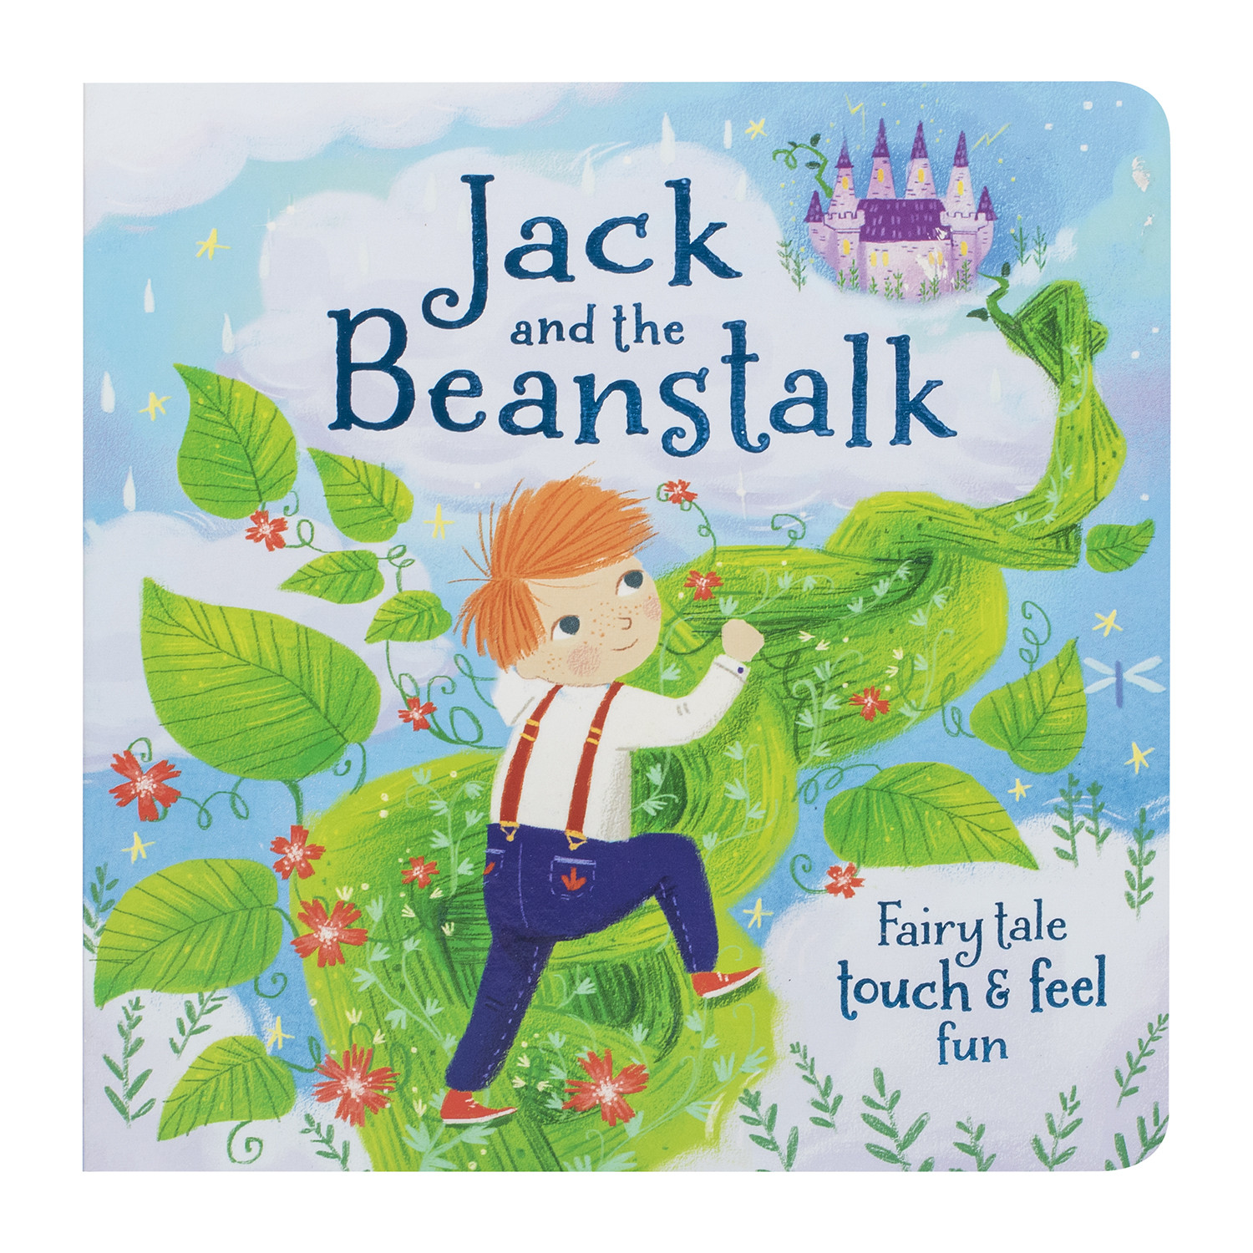

Understanding the World

Can you use a tablet or smart phone to record yourself retelling the story of Jack and the Beanstalk? Once you’ve finished, ask your parents to post your video on Tapestry.

Do some planting in your garden. What will you grow? How will you look after these plants?

Physical Development

P.E. with Joe (YouTube) or Andy’s Wild Workout (CBeebies iPlayer)

Can you create your own beanstalk leaves? Use a wax crayon or colour pencil to make leaf rubbings.

Phonics

Please see Tapestry for your daily phonics session.

In the meantime, keep practising by watching Alphablocks on CBeebies iPlayer.

**Home Learning – Sparrows**

**Week Five**