Natural Dyeing

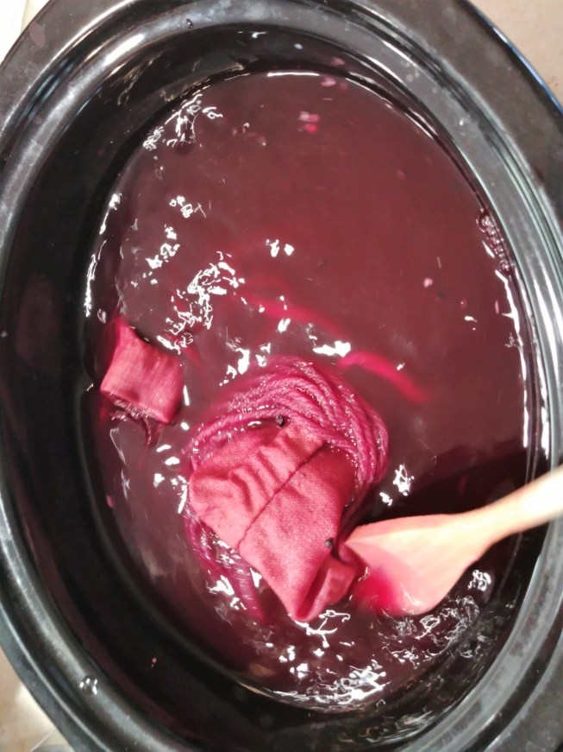
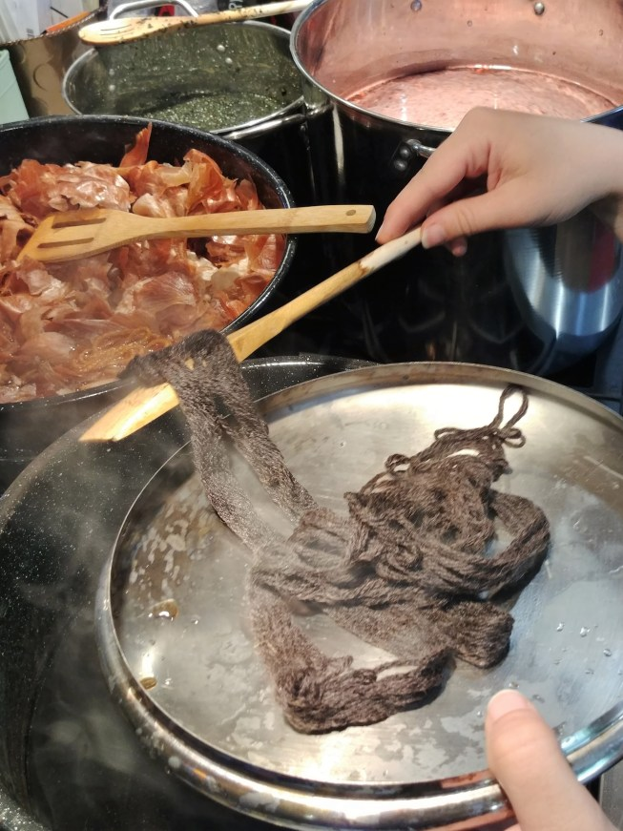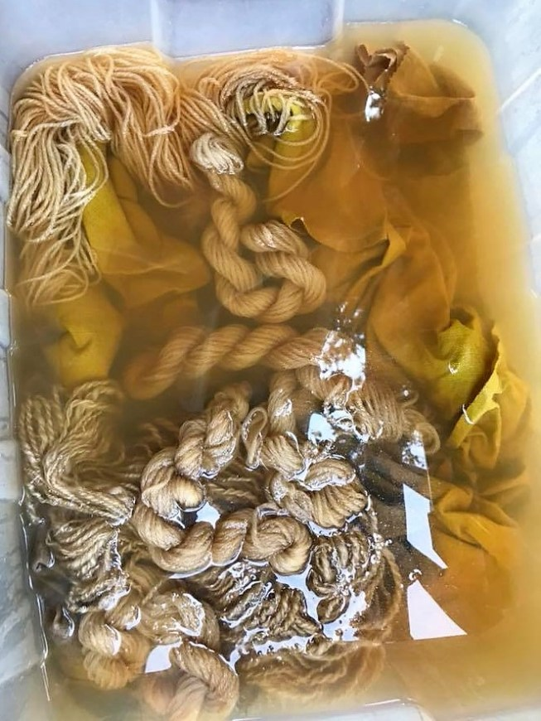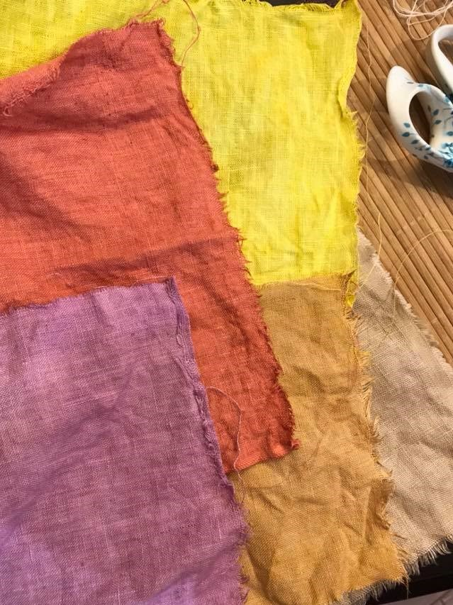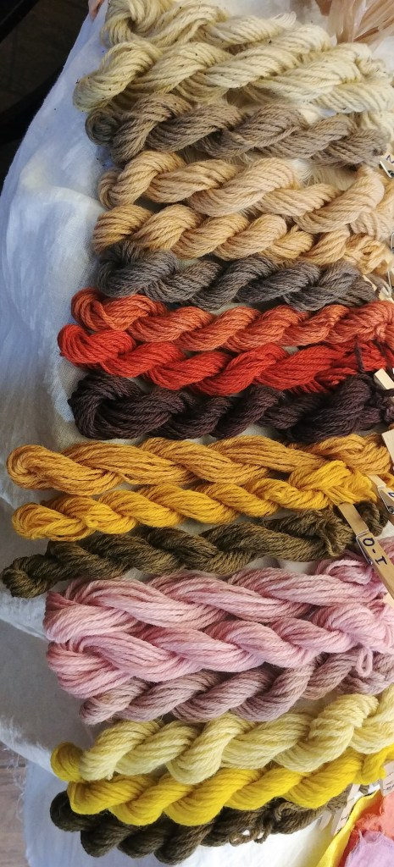
You can make dye with almost any natural plants, leaves, bark etc. You could try: onion skins, red cabbage, nettles, beetroot, tea , turmeric, soft fruits etc. Have fun and experiment, but only do this with an adult. Make sure you use an old pan- it will stain, but gradually fades. Plain white cotton (an old t-shirt, sheet etc) works best.
To make the dyes you will need to chop up the ingredients and boil them in water. Add the fabric and boil it in the dye. The longer you boil, the deeper the colour should be. Don’t add too much water as you will dilute the dye.

