**English**

Look through your Jungle books and pictures. Discuss and describe a rainforest in as much detail as you can. Use describing words (adjectives) and explore new vocabulary. Can you write a description of at least 4 to 8 separate sentences and use these conjunction words to extend your sentences?

and or but so because if when

**Maths**

What’s the time? Practice reading the time to o’clock, half past and ¼ past

* Daily Maths Whizz (30 minutes)
* **Please see Hamilton free home learning packs for Y1 and Y2**

<https://www.hamilton-trust.org.uk/blog/learning-home-packs/>

* Also NRICH have some free and fantastic games and activities suitable for working from home

https://nrich.maths.org

**Skylark’s**

**Home Learning ☺  
Week 3**

**Computing**

Use the scratch link on the school website.

**Geography**

Locate Brazil on world map, globe and look closely at a map of Brazil. *\* see attached map and question sheet*

Locate Amazon rainforest & river.

Discuss the map and answer the questions.

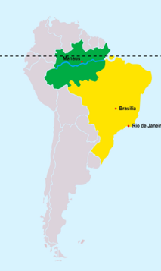

**Music**

Sing some Jungle songs!

Here are a few:

<https://www.twinkl.co.uk/resource/t-t-2546004-jungle-and-rainforest-songs-and-rhymes-resource-pack>

Find more.

Make up your own. ☺

**Art**

Make your own Rainforest head dress or head band – go wild!

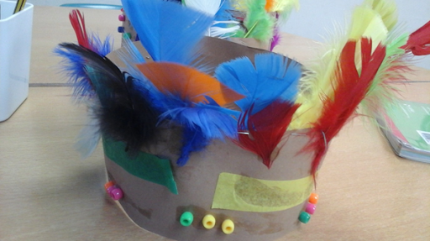

**Science**

Find out about the 6 scientific animal classification groups.

Mammals/reptiles/amphibians/birds/insects and fish.

Focus on rainforest fish and birds.

Draw and label a fish and a bird.

Discuss their features and why they have them.

**P.E.**

Use Joe Wicks live PE session for a stronger work out

<https://www.youtube.com/channel/UCAxW1XT0iEJo0TYlRfn6rYQ>

OR Cosmic Yoga for a gentler stretch and active stories

<https://www.youtube.com/user/CosmicKidsYoga>

Down in the Jungle

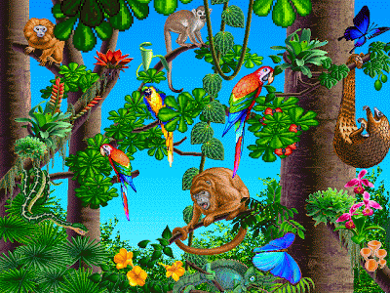

Animal classification clip:

<https://www.youtube.com/watch?v=mRidGna-V4E>