**Maths Mass/Weight** 

Follow a recipe to make something simple. Try and include a food that has come from the Rainforest

Can you weigh out all the ingredients yourself? Look at the measurement used for weight g/kg

Find food in your kitchen, such as a tin of beans. Can you find something which is heavier and something which is lighter? Look for the weight labelling on food products

**Skylarks’**

**Home Learning ☺  
Su:2 Week 1**

**Rainforest recipe**

**Science**  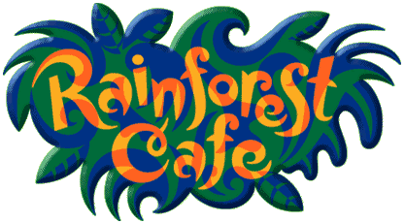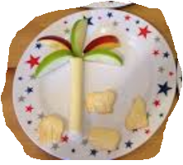

What food comes from Rainforests around the world? Do you have any in your cupboard?

Can you make a Rainforest snack? You could even set up your own pretend Rainforest café!

**PE**

Have a game of physical Battleships and try a 60 second challenge!

\**see attached sheets*

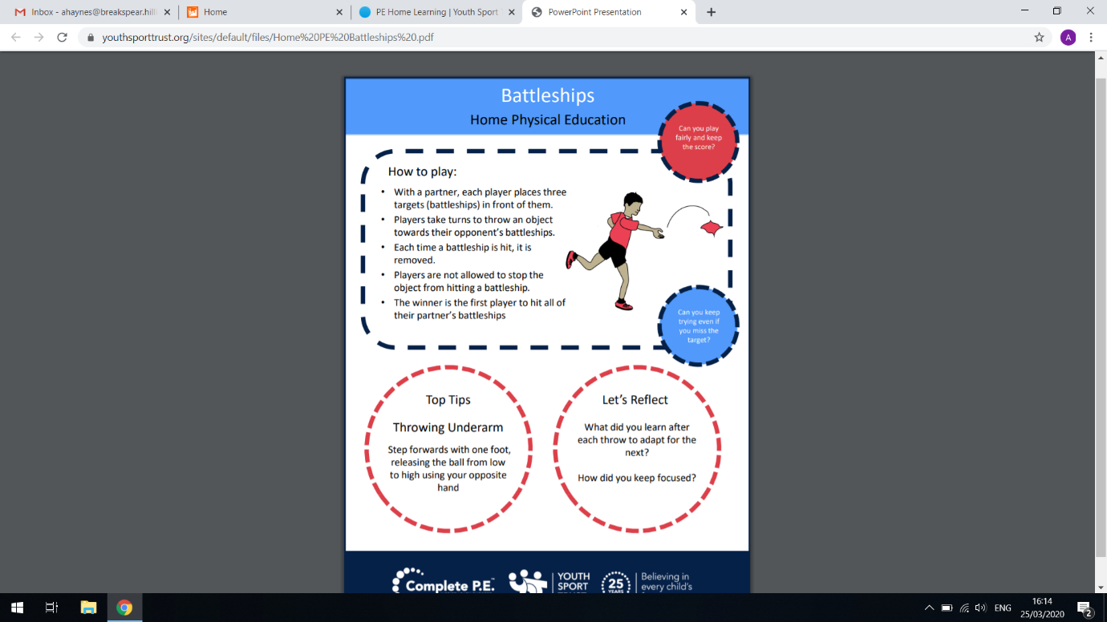 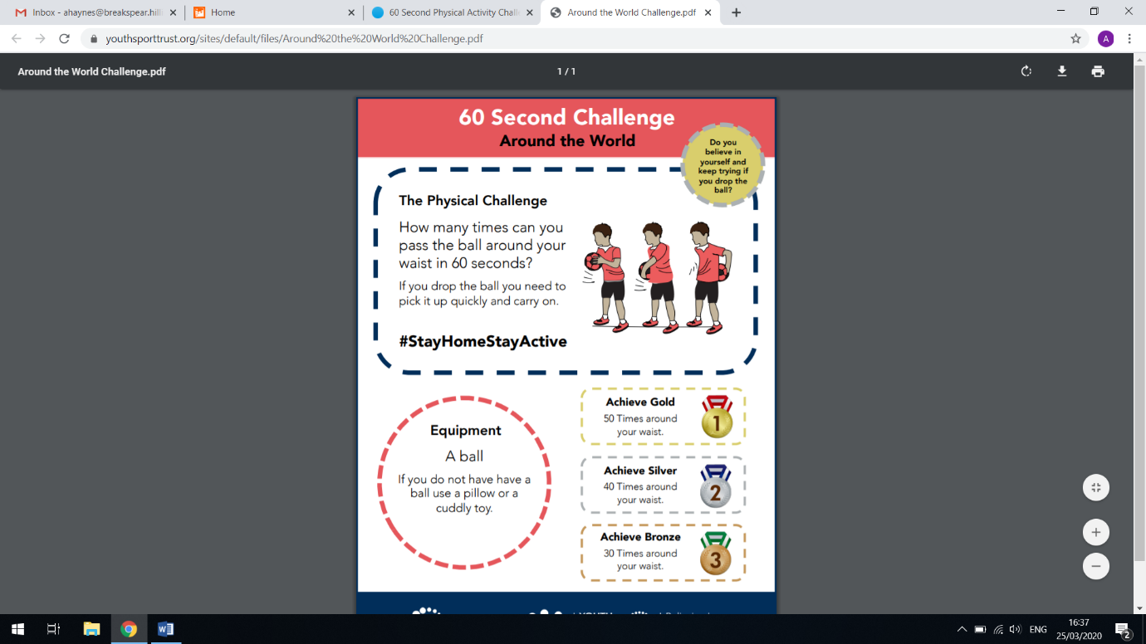

Roaming the Rainforest

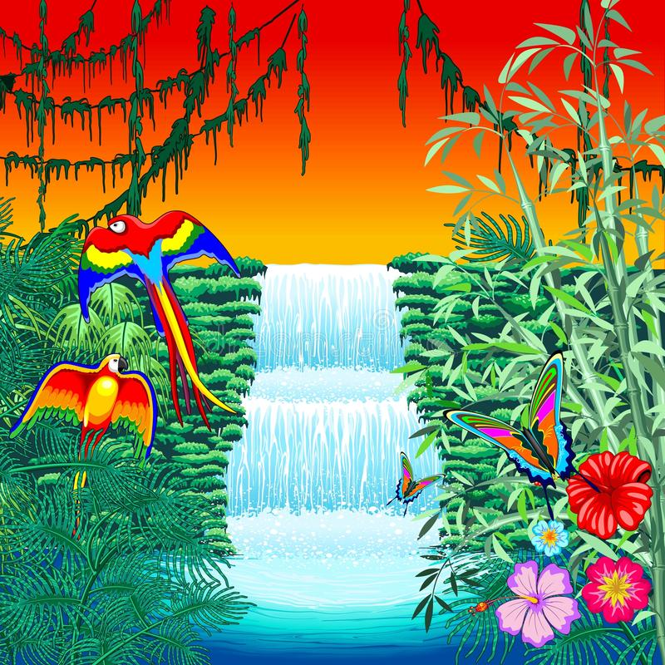

Animal patterns

<https://www.bbc.co.uk/bitesize/clips/zpn6n39>

**PHSE –**

What do we know about the Coronavirus?

Establish Shared thinking, facts, dispel hearsay/myth busting

Use Axel Scheffer’s book to illustrate coronavirus facts

<https://axelscheffler.com/books-for-older-children/coronavirus>

Generate word bank of ‘new’ words we have heard: Pandemic, virus, loss, frontline, key worker etc

How can we stay safe? Look at new rules for school and outside of school. Go over new routines. Posters? Info leaflets?

**Art/D. T**

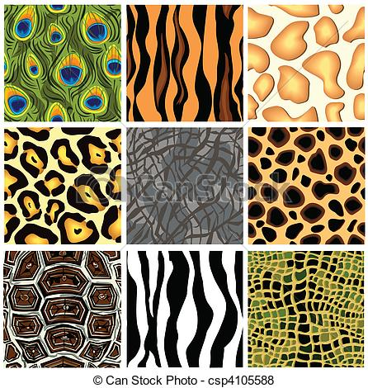

Look at some images of Rainforest animals- can you describe the patterns? Do you know why the animals have their colours and patterns?

Start to sketch or draw some patterns on paper & have a look at the help sheets to give you some ideas

\**see attached sheets*

**English**

Write out a recipe for a yummy rainforest treat!

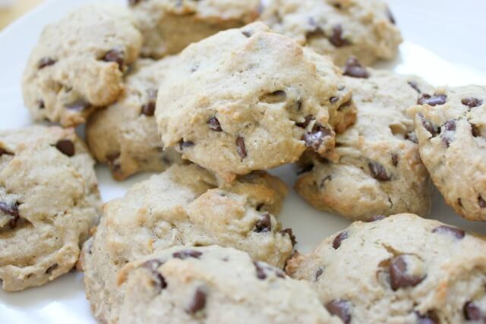

**Geography** 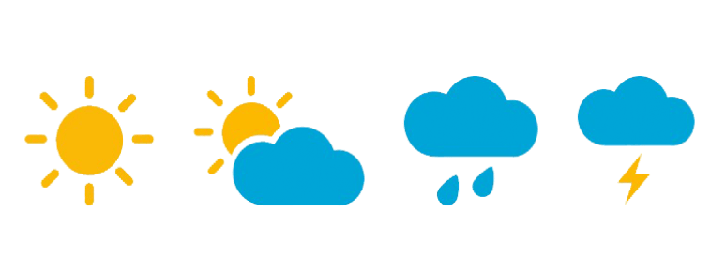

Find out about the weather in the Amazon Rainforest.

How does it compare to the weather in the U.K?  
Can you write your own weather report or draw some weather symbols?