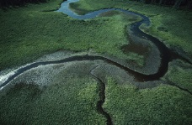
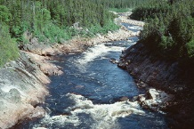
The Journey of a River

Introduction
All rivers follow a similar journey, beginning at their source and ending at their mouth, or delta, where they reach the sea or the ocean. Rivers change the land as they flow over and through it, through a number of processes: erosion (wearing away the land), transportation (moving sediment) and deposition (dropping sediment). Each of these processes happens more at some stages of a river’s journey and less during other parts of its journey. Read on to find out all about the various stages of rivers and how rivers change throughout their journeys!

Young River - Upper course
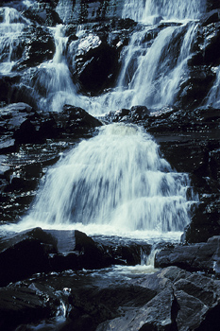
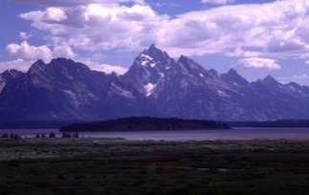
The river begins at its source, which is usually high up in hills or mountains; for example, the River Ganges begins in the Himalayas. Some rivers begin with a spring (when water bubbles up from underground), whereas some begin as a small stream formed from rainwater or melting ice or snow. To begin with, the river does not have much power. However many small tributaries join it at confluences, meaning that it quickly gathers momentum and is powerful enough to carve out a narrow channel in the rocks that it flows over. Although the river is shallow, its speed means that it is powerful enough to erode rocks and to transport sediment (bits of rock and soil). Often rivers will have waterfalls in their upper course, where water cascades over the edge of a rock and falls through the air. As it travels, it cuts a v-shaped valley through the land by eroding softer rocks, such as sandstone, more easily than hard rocks, such as granite.
Waterfalls
Mountains

Middle course
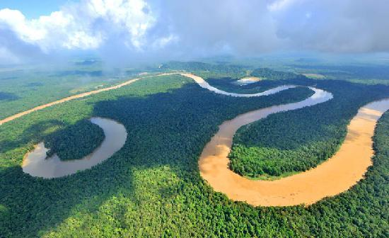
In its middle course the river widens, deepens and travels more slowly. Although it can look very slow and calm on its surface, it still has great power and continues to transport sediment. Because of the sediment that it is carrying, the river may look dark brown and murky. At this point, the river will flow through its flood plains (areas that are flooded when the river breaks its banks). When rivers floods fields, they deposit sediment (or silt) on the fields. This makes the fields fertile (good for growing crops on). In addition, the river starts to meander (bend). On the outside of these meanders, the river flows more quickly; hence the bank on the outside of the meander is eroded more quickly than the bank on the inside of the meander. Some of the sediment from this erosion will fall to the river bed; some of it will be transported further down river and some of the river’s sediment is deposited on the inside bank of the meander, where the water is travelling more slowly. When a lot of sediment is deposited on this inside bank, an ox-box lake can be formed. Usually with time, an ox-bow lake will disappear as it does not receive a fresh supply of water and it fills up with sediment.
Meanders and an ox-bow lake

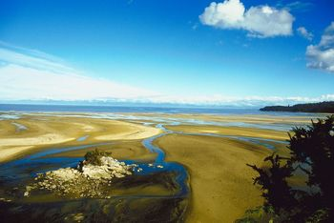
Lower course – Old River
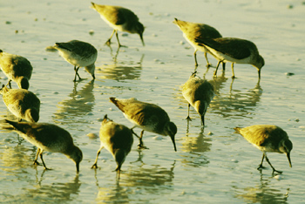
In its lower course the river is nearing its final destination: the sea or the ocean! During its lower course, the river is at its widest and slowest. The river now has less energy; therefore it drops the sediment that it has been carrying. Sediment can form islands and the river can split into smaller channels. Where islands and channels form in this way is known as a delta. Where the fresh water of the river starts to mix with the salty water of the sea is known as an estuary. Deltas and estuaries can form mudflats, which can be exposed when the tide goes out and can be submerged when the tide is in. Mudflats can be important breeding grounds for wading birds and other wildlife. Large ships can use the estuary to sail up the river from the sea or the ocean. Because of the sediment build-up, it can be necessary to dredge the sediment out of the river, so that these large ships can continue to use it.
Mudflats
A delta

Summary
Rivers begin at high points in hills or mountains and are then joined by other streams and rivers at confluences. A river has three main stages: upper course, middle course and lower course. As rivers travel they become slower, wider and deeper. When they flow more quickly, they transport more sediment; when they travel more slowly, they deposit this sediment. Almost all rivers end their journey by reaching a sea or an ocean.

