History Research: <http://www.fun-facts.org.uk/vikings/viking_homes.htm>

<https://www.bbc.co.uk/bitesize/clips/zrthfg8>

<https://www.youtube.com/watch?v=D8ba5tt6Sqo>

What were Viking houses like?

How were they made? What materials were used? How do we know? Why is there so little evidence left?

Write up your findings and draw a labelled diagram.

English: Beowulf

Watch parts 1-3 of the animated version ofBeowulf: <https://www.youtube.com/watch?v=9B28kRgCZjk>

Now write the story so far, in your own words. Make it as exciting as possible, using the synopsis, word-bank and phrase sheet to help you.

Geography

Draw a diagram of the Water Cycle, with labels and text to explain it.

<https://www.bbc.co.uk/bitesize/topics/zkgg87h/articles/z3wpp39>

<https://www.youtube.com/watch?v=U80LVjVX75k> See: Glossary of terms

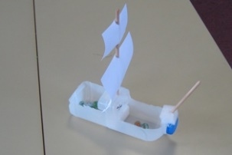

R.E. Watch:<https://www.youtube.com/watch?v=jDc4CJscWws>

Can you find out about the Hindu place of worship- The Mandir?

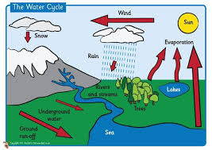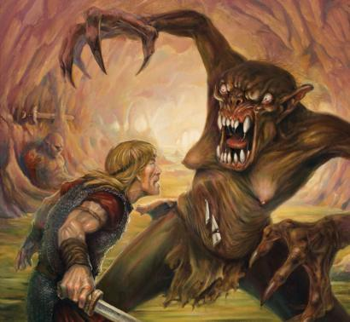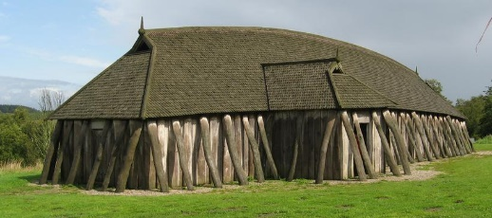

D.T. Now it’s time to put your designs to the test! Ask an adult to cut a plastic milk bottle in half lengthways for you. Use this as the hull. You will need to add a scary figurehead, shields, oars, mast and sail. Perhaps you could even add some Viking figures! Don’t rush, you have 2 weeks.

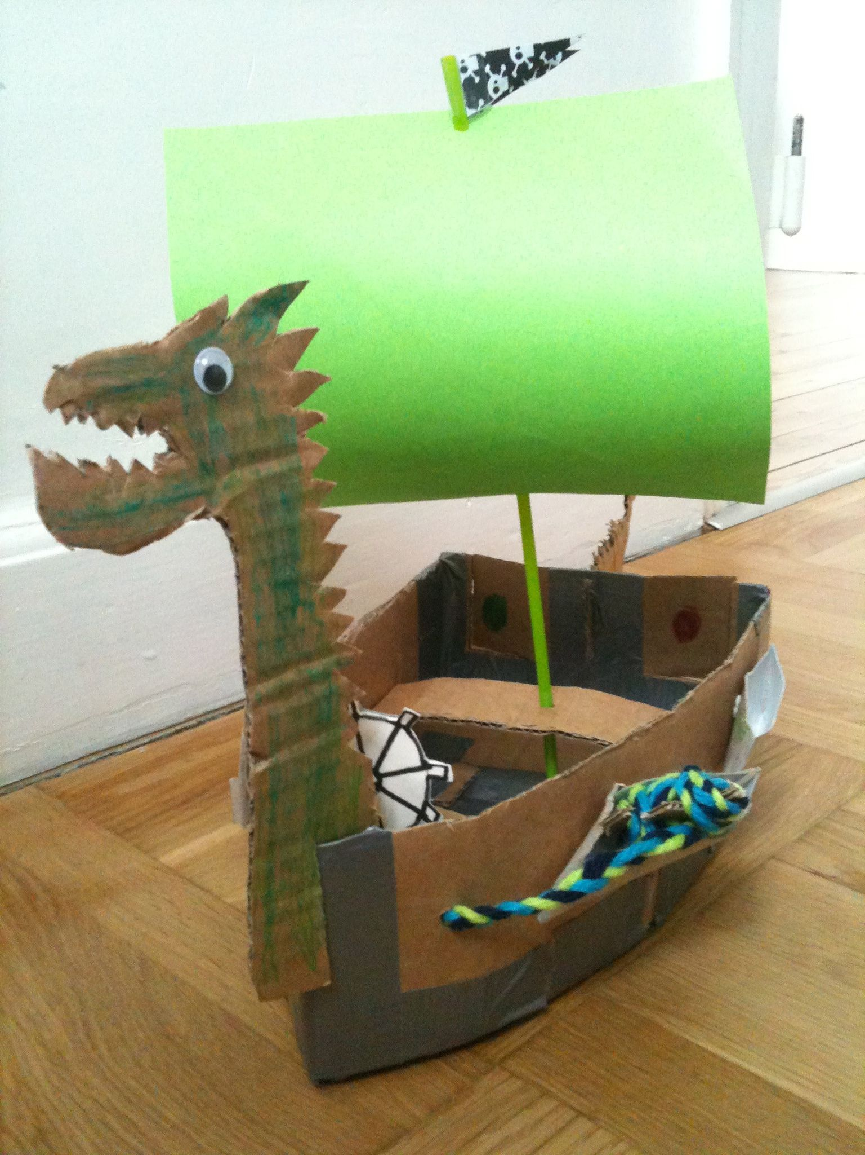

Vikings

Week 4

Maths This week I want you to concentrate on Maths Whizz. I have also set you a challenge to make a paper plane. www.bbc.co.uk>newsroundpaper planes Fly it 10 times and record the distance it flies. If you don’t have a tape-measure, record in steps. What happens if you use a smaller piece of paper? Try a different design. Have fun.

Science : Dissolving Watch:<https://video.search.yahoo.com/search/video?fr=mcafee&p=dissollving+ks2#id=4&vid=85b525ae436e834c8a9729df088ca421&action=click> <https://www.bbc.co.uk/bitesize/topics/zcvv4wx/articles/zpbdpbk>Write up in your own words then try the experiment with an adult. (see separate sheets)