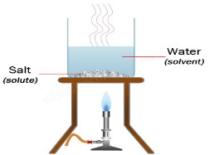

Geography

Research and write about the journey of a river, from the source to the sea. Draw a diagram to show the 3 stages of the river, labelling features. Or you might like to make a model with plasticine. (See separate help sheets)<http://www.primaryhomeworkhelp.co.uk/rivers/stages.html>

English: Beowulf continued

Watch parts 4-6 of the animated version of Beowulf:<https://www.youtube.com/watch?v=9B28kRgCZjk>

Finish writing the story. (Remember to use the sheets from last week to help you.)

Did you enjoy the story? What was your favourite part?

R.E.

Find out about some different Hindu gods .

(Use attached worksheet if you would like to.)

<https://www.youtube.com/watch?v=-ZrZTLo6tGQ>

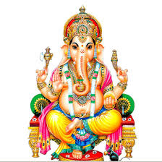

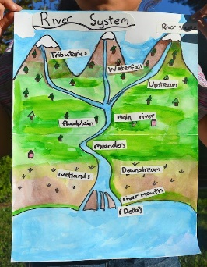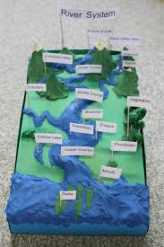

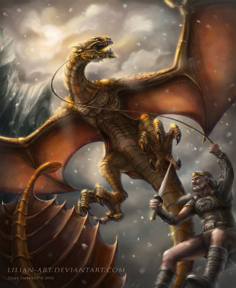

Science

Evaporation, condensation, distillation and filtration

<https://www.bbc.co.uk/bitesize/topics/zkgg87h/articles/zydxmnb>

How does this relate to the water cycle? <https://www.bbc.co.uk/bitesize/clips/zb9c87h>

Have a go (with an adult)

at separating salt from water by

evaporation.

Is this a reversible or irreversible?

change?

Vikings

Week 5

History

Research and write about the clothes that Vikings wore. Draw labelled illustrations.

<https://norsemythology.net/viking-clothes/>

<https://www.bbc.co.uk/bitesize/clips/zksfb9q>

[http://www.fun-facts.org.uk/vikings/viking_clothing. htm](http://www.fun-facts.org.uk/vikings/viking_clothing.%20htm)

DT

Continue making your Longboat. Try it out in the bath. Is it fit for purpose?

Can’t wait to see them!

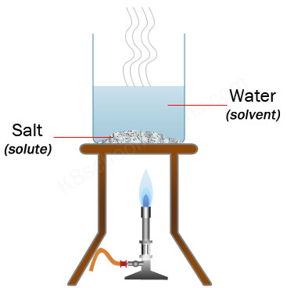

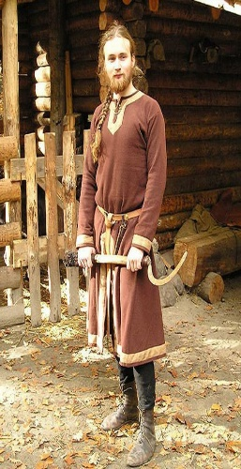

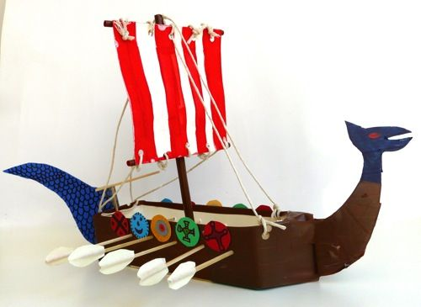

Maths Maths Whizz

Challenge: Go for a walk and measure the circumference of at least 6 trees (about a metre from the ground.) 2.5 cms = 1 year’s growth. Work out their ages.