**Maths**

Let’s brush up on our addition and subtraction skills this week. Record any number sentences that could be relevant to what is going on at home. Can you make up some real life +/- problems?

* Daily Maths Whizz (30 minutes)
* **Please see Hamilton free home learning packs for Y1 and Y2**

<https://www.hamilton-trust.org.uk/blog/learning-home-packs/>

* Also NRICH have some free and fantastic games and activities suitable for working from home

https://nrich.maths.org

**Skylark’s**

**Home Learning ☺  
Week 4**

**English**

Animal fact files

Choose 1 animal from each of these 3 animal groups mammals/reptiles/amphibians

Now write 3 fact files for each one.

**Music**

Listen to The carnival of the Animals by Camille Saint-Saëns.

<https://www.youtube.com/watch?v=1L993HNAa8M>

Can you guess which animal? What is happening in the music? Fast/ slow or loud/soft. Can you move to the music like the animal?

**Geography**

**Have a look at the picture –**

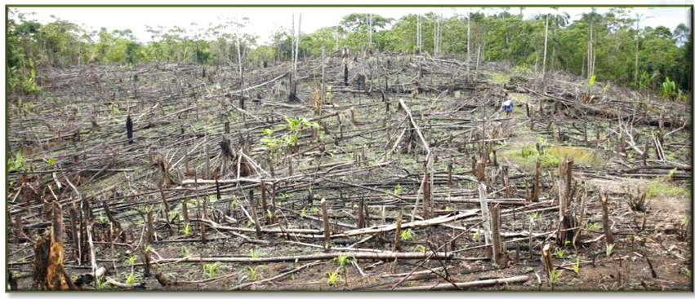

What can you see? What can you guess? What can you predict?

*\* see attached sheet*

**Art Make a monkey!**

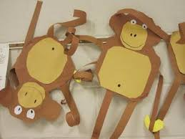

*\* see attached sheet for more ideas*

Roaming the Rainforest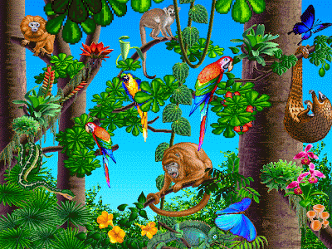

Monkey-All Things Animal TV

<https://www.youtube.com/watch?v=owr198WQpM8>

**P.E.** Use Joe Wicks live PE session for a stronger work out

<https://www.youtube.com/channel/UCAxW1XT0iEJo0TYlRfn6rYQ>

OR Cosmic Yoga for a gentler stretch and active stories

<https://www.youtube.com/user/CosmicKidsYoga>

**Science**

Classify the animals! Cut and stick the pictures and sort into the correct groups.

\**see attached for pictures and sorting board to print* – or make own!

**Computing**

Use the scratch link on the school website.