**Maths**

Let’s brush up on our multiplication and division skills this week. Focus on the x2/x3/x5/x10 times tables for both x and ÷ problems.

Daily Maths Whizz (30 minutes)

* **Please see Hamilton free home learning packs for Y1 and Y2**

<https://www.hamilton-trust.org.uk/blog/learning-home-packs/>

* Also NRICH have some free and fantastic games and activities suitable for working from home

https://nrich.maths.org

**Skylark’s**

**Home Learning ☺  
Week 5**

**English**

Animal fact files

Choose 1 animal from each of these 3 animal groups

birds/insects/fish

Now write 3 fact files for each one.



**Geography**

**DEFORESTATION**

What does it mean and how can we help?

**Art**

Make some jungle vines from paper chains.

Draw and colour some Rainforest insects, make them as clear and bright as you can.

Now cut them out and stick them onto your hanging vines. Why are insects important?

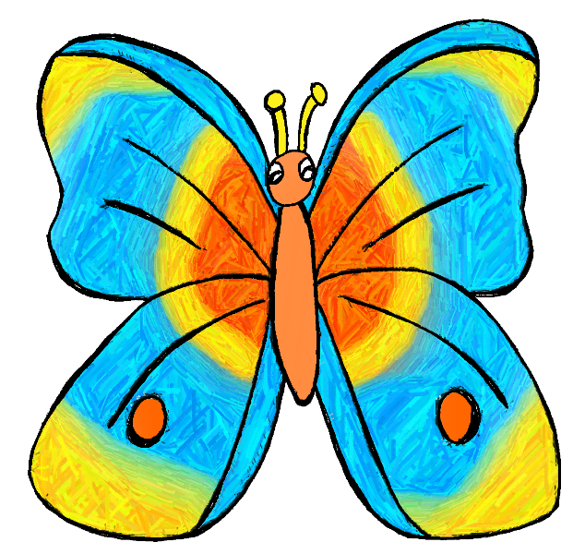 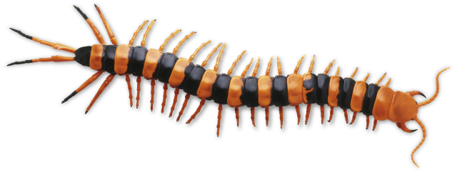

**Computing**

Use the scratch link on the school website.

**Music**

Can you use the instruments you made in week 2 or any other instruments or objects around you and your voice or body to make a Jungle Sound Story?

Watch this clip for ideas.

<https://www.bbc.co.uk/programmes/p011stvj>

**Science**

Name the animal groups and discuss, describe and write down what the animals in each group have in common.

*\* see attached sheets to print or copy*

**P.E**

Use Joe Wicks live PE session for a stronger work out

<https://www.youtube.com/channel/UCAxW1XT0iEJo0TYlRfn6rYQ>

OR Cosmic Yoga for a gentler stretch and active stories

<https://www.youtube.com/user/CosmicKidsYoga>

Roaming the Rainforest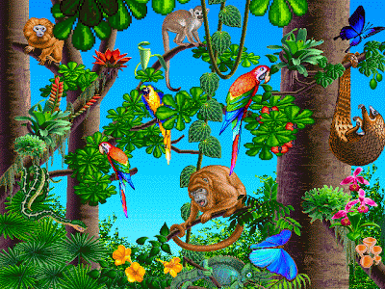

Rainforest insects

<https://www.activewild.com/rainforest-insects/>