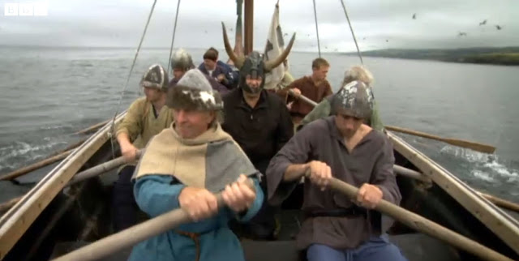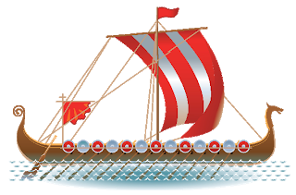

Maths

As last week, go to: <https://www.hamilton-trust.org.uk/blog/learning-home-packs/> (Week 4)

Y5: Column addition/ subtraction /negative numbers

Y6 Fractions, Ratio/ Shape

Geography

Can you find out about Saxon and Viking place names?

Then complete the worksheet.

**Saxons and Vikings**

**Week 3**

**Week 3**

English

Imagine you are a Viking on a longboat, rowing to England. Write a conversation between yourself and some of your crew-mates. You can talk about your voyage, lack of food, conditions on board, weather, etc. You could try and make it humorous! (They would be cold, tired and probably very bad-tempered! (See help sheet.)

Science <https://www.bbc.co.uk/bitesize/topics/zcvv4wx/articles/z9brcwx>

<https://www.youtube.com/watch?v=tHM0UkhwfsQ>

Explain what reversible and irreversible change means, and the ways materials can be changed.

Draw and label examples of each. (see separate sheet.)

RE: Hinduism

Draw your own Puja plate, and say how each object is used. (There is a worksheet if you prefer to use it.)



History

Find out about Viking Longboats.

Watch: <https://www.bbc.co.uk/bitesize/clips/zrwbwmn>

<https://www.youtube.com/watch?v=yB4s3nQtZqE>

Useful Info:

<http://www.funfacts.org.uk/vikings/viking_ships.htm>

<https://wiki.kidzsearch.com/wiki/Longship>

How were they designed and built?

Make a poster. Draw a longboat in the middle, with facts all around it.

Art /DT

Draw a design for your own Longboat, including sail, oars, shields and figure-head. You need to think what materials you need and label your diagram. Remember it has to be fit for purpose.

Think about using half a plastic bottle as the hull.