Outdoor Maths
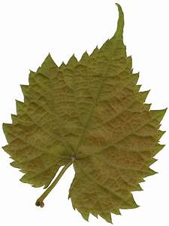
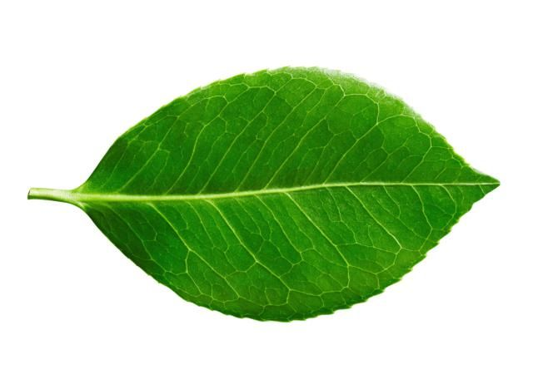 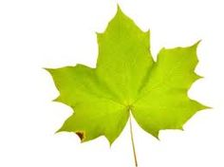Collect 10 leaves.
Measure the length of each.
Find the range, mode, median and mean of your measurements.

Remember you need to put your measurements in order first.
The range is the difference between the largest and the smallest.
Median is the middle number ( If you have 2 middle numbers you have to find halfway between them.
Mode is the number that comes up most often. ( You might not have one.)
Mean is all the numbers added together and divided by the number of leaves you have, (in this instance 10.)

Repeat with the width measurements.

Magic Square
Find 4 sticks to make a 3x3 grid. (Or draw with chalk.)
Put different amounts of natural objects in each square so that each row, column and diagonal adds up to 15.
You can use each number from 1-9 once only.
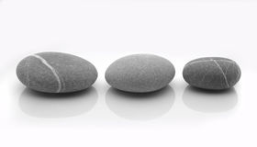
Take a photograph. 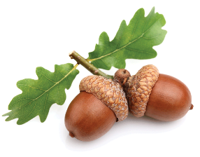

Challenge: Can you make a 4x4 grid that adds up to 34?

