Separating Mixtures
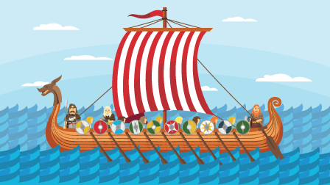
You are aboard a Viking longboat set for East Anglia.
Unfortunately all your provisions have got mixed up and soaked in sea water.
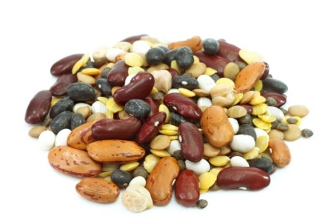
Your task is to separate the mixture which contains:
- Dried cod
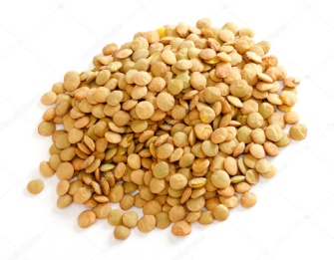
- Beans
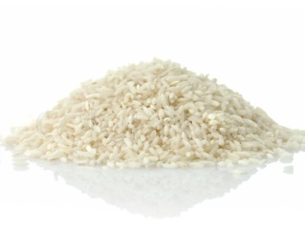
- Lentils
- Rice
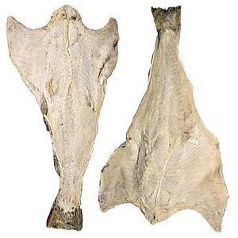
- Small stones
- Salt water
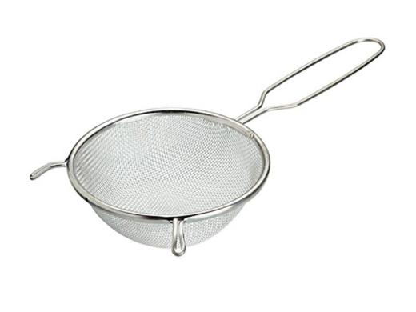
Apparatus available:
- Containers
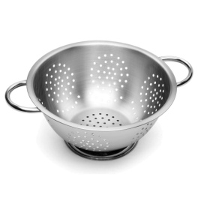
- Colanders
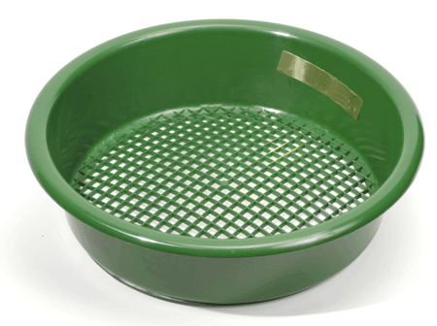
- Sieves
- Filter paper
- Hob
- Saucepan

Are you up for the challenge?
- Record your experiment using diagrams and photographs.

