

**PE**

Climb the ladder and 60 second challenge

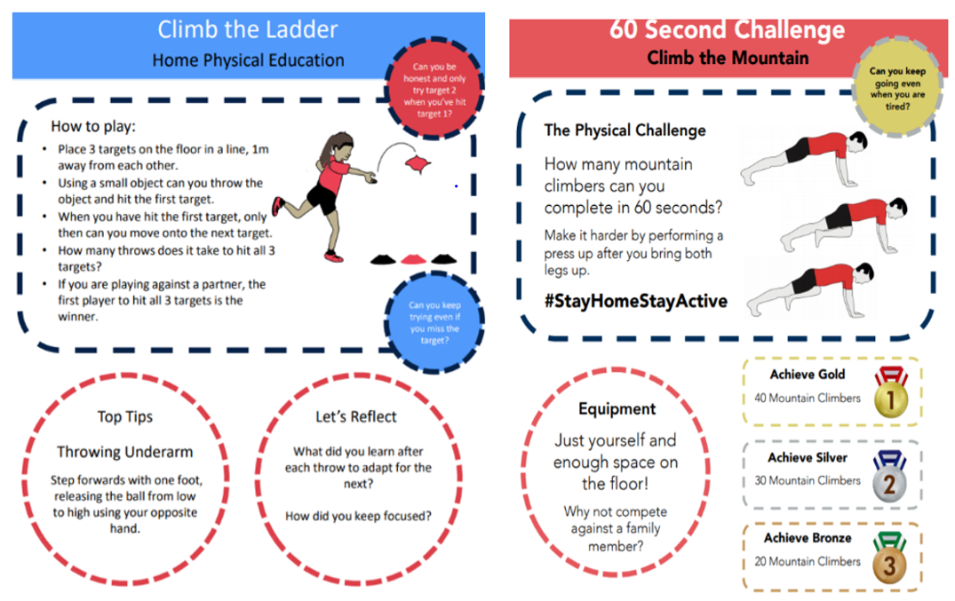

**Science**

Plants of the Rainforest

Have a look at the activity sheets. Can you write some sentences describing the plants that grow in the Rainforest?

\**see attached sheet*

**Maths**

Number facts

Take your time to fill in the empty addition grid, you may use the colour filled in grid to help you

\**see attached sheets*

Spend 10 minutes each day practising your number bonds, doubling & halving and times tables.

Link to a website for practising:

<https://www.topmarks.co.uk/maths-games/hit-the-button>

**PHSE** 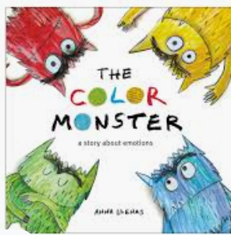

The Colour Monster – exploring feelings

<https://www.youtube.com/watch?v=bpLmzxbeVmU>

The little girl puts the Colour Monster’s feelings into separate jars. Draw things that make you happy/ angry/sad etc.

**Geography**

Layers of the Rainforest

Watch the clip:

<https://www.youtube.com/watch?v=ea82OEf91C4>

Now draw your own or colour the picture attached and add the labels to show the different layers of the Rainforest.

\**see attached sheet*

Roaming the Rainforest

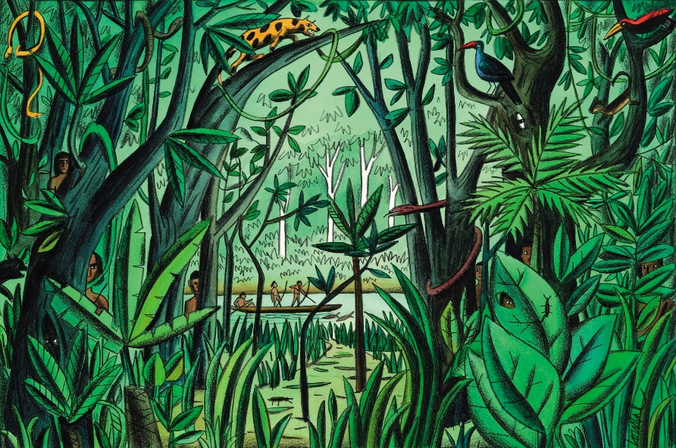

Plants of the Rainforest:

<https://www.youtube.com/watch?v=iKEPvcxnEck>

**Art/D. T**

Animal pattern paintings

Following on from last week’s work, can you produce a painting using colours, shapes, lines, texture and tones to produce a painting?

You don’t need to paint the animal – just the patterns – it doesn’t even need to be realistic, be inspired by animal patterns and colours!

**English**

**Rainforest senses poem**

Make a collection of rainforest words that link to your senses. Write a poem using the sentence starters-

In the Rainforest I can see…etc.

**Skylarks’**

**Home Learning ☺  
Week 2**