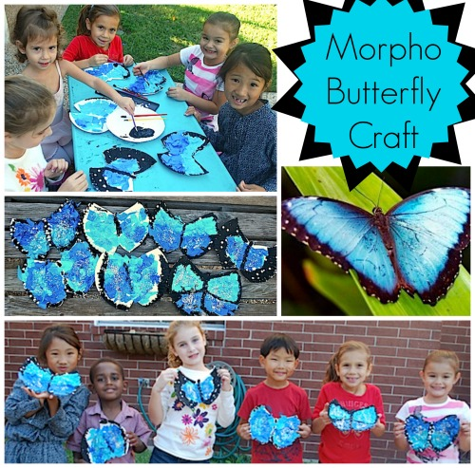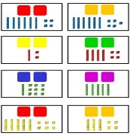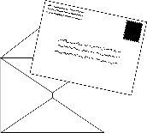**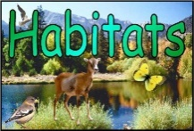

Find out about morpho butterflies.

Paper plate

Paint blue black and white

Sparkles

**Art/D.T**

**Geography**

People of the Amazon Rainforest

Read the letter from Akra to or with an adult.

Discuss the things that are different or the same as your day.

Can you fill out the comparison sheet?

***\*see attached sheets***

**English**

**Watch/read and discuss the story The Great Kapok Tree**

<https://www.youtube.com/watch?v=J1Teb-_jTyI>

Can you write a new page for the story, choosing a new animal and thinking about what the animal might say to the man…

Roaming the Rainforest

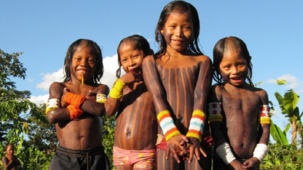

Watch and discuss with a grown up:

<https://www.youtube.com/watch?v=yu88xsGweZs>

**PHSE**

Staying connected

Discuss people who are important to you.

Family,friends, people at school or a club.

Think of ways that you can stay connected and communicate with them- a phone call, a card or letter…

Maybe you could draw a picture for Skylarks and send it to school…

***\*see attached sheet for ideas***

**Skylarks’**

**Home Learning ☺  
Week 3**

**Maths Play with Place Value**

**Watch the clip:**

<https://www.youtube.com/watch?v=vBIZal-8Kr4&list=PLWIJ2KbiNEyplZvdo0-OU48R3KSq3ywhV&index>

Make your own tens and ones using straws, tooth pics or pencils for the 10s and raisins, stones or beads for the 1s (or anything else you can think of). Have a go at using them to make different 2-digit numbers.

Use plates to make your own part-whole models.

Once you are confident, have a go at drawing out your tens and ones as pictures.

CHALLENGE- Cut out some square shapes to represent 100s and have a go with 3 digit numbers.

**PE**

Rolling penalties and 60 second challenge

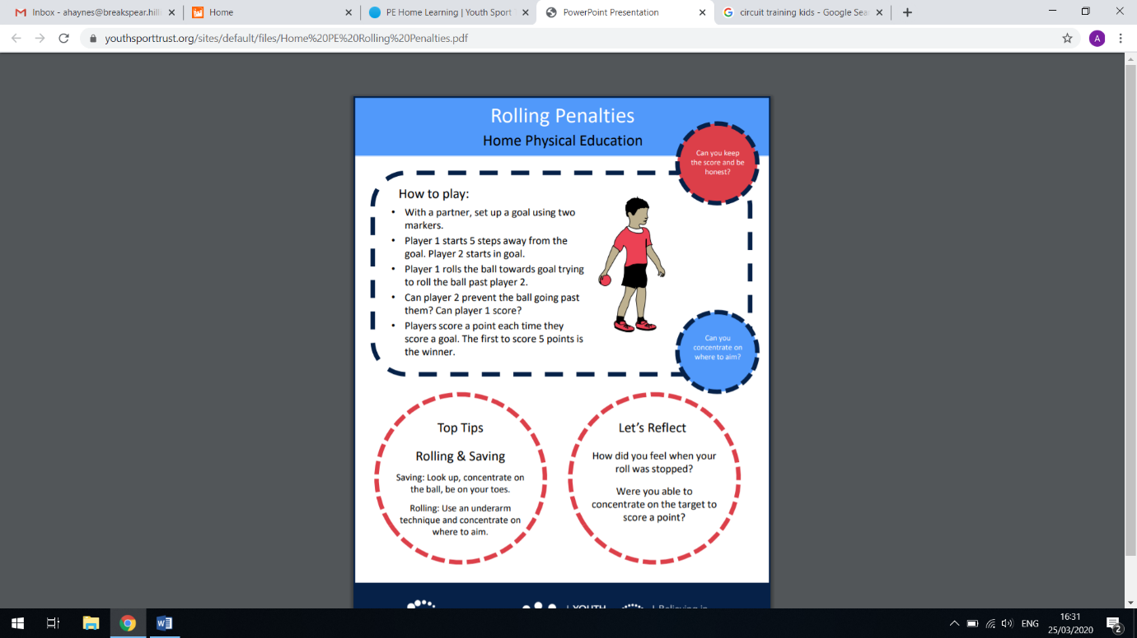 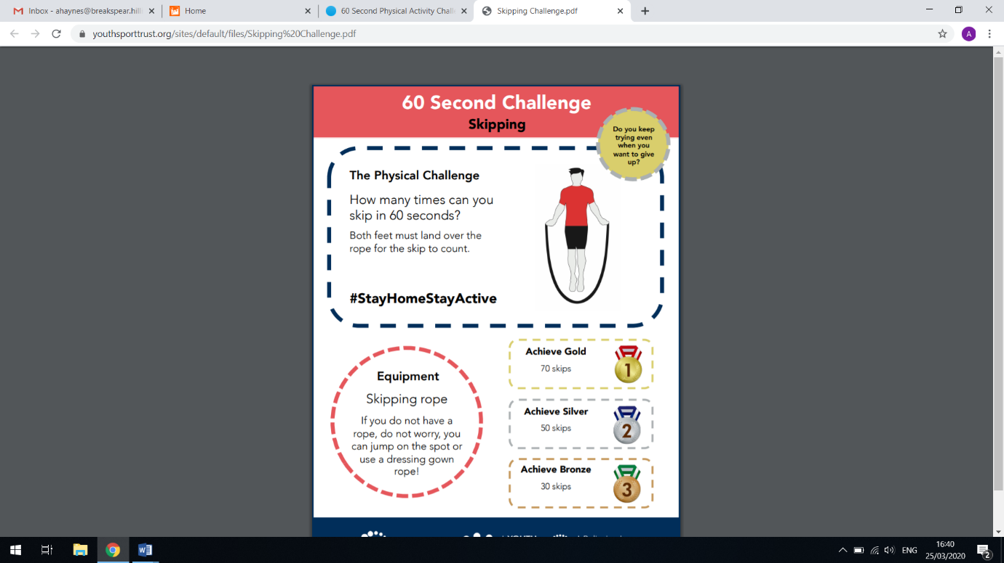

**Science**

What is a Habitat?

Explore different habitats around the world

**Can you name the habitats as large, small or micro?**

**Match animals to their own habitats**

**How are the animals suited to their habitats?**

***\*see attached sheets and Powerpoint presentation for support***