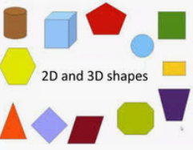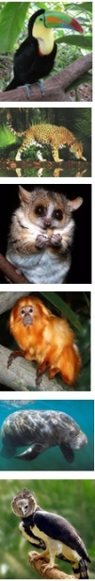

**Geography**

What is an ariel photo? Have a look at the ones I have attached and even try google earth to look at and discuss the features of a Rainforest – notice vegetation, landscape, human impact, weather patterns and presence of water.

*\*see attached PPT for ariel photos*

**PHSE**

Ways to feel better

Discuss times when you may have felt difficult feelings such as sadness, frustration anger etc. What can we do to make us feel better or cope with the feelings? *\*use the help sheet attached*

**PE**

**Standing long jump and 60 second challenge**

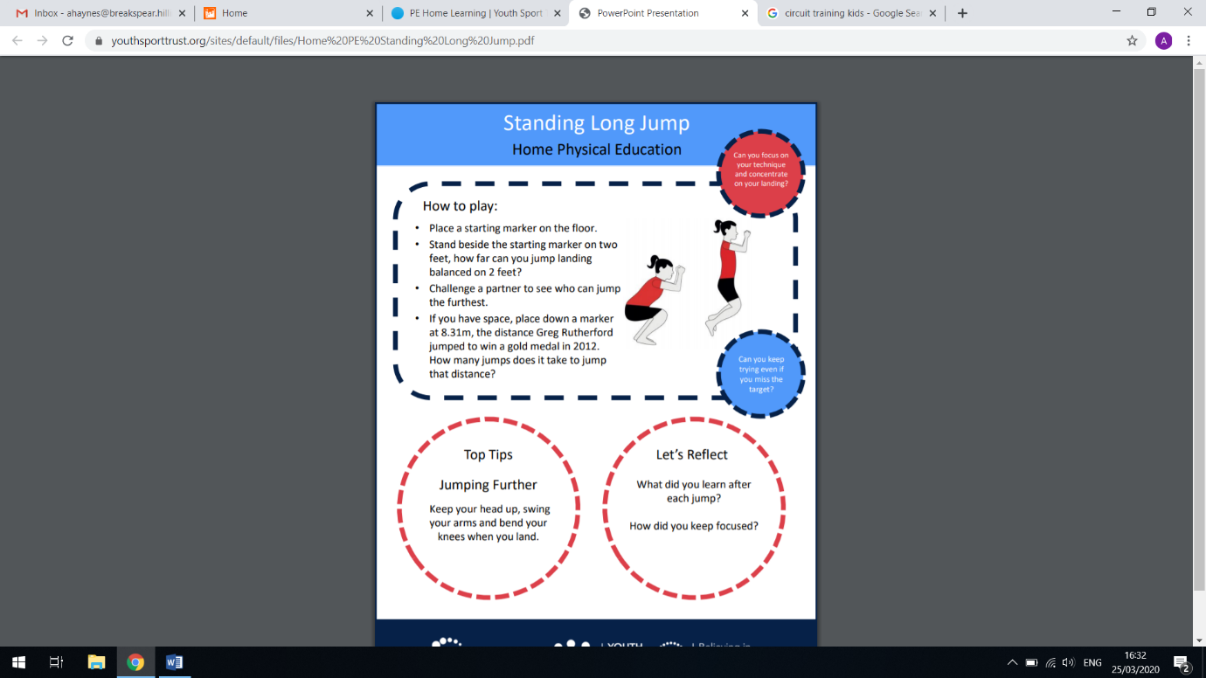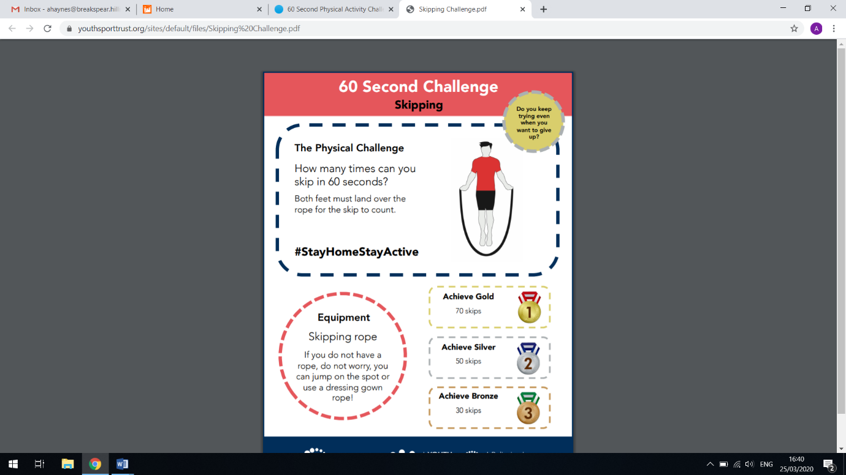

**Science**

**Rainforest habitats**

What does **ENDANGERED**

mean and how is that linked to animal

habitats?

Find out about some of the endangered

animals of the Rainforests and write

down some facts about the animals and

their habitats.

**Art/D. T**

**Rainforest di** **orama or collage**

Can you use an old shoe or cereal box to create a Rainforest scene? Or create a picture using different painting and collage techniques

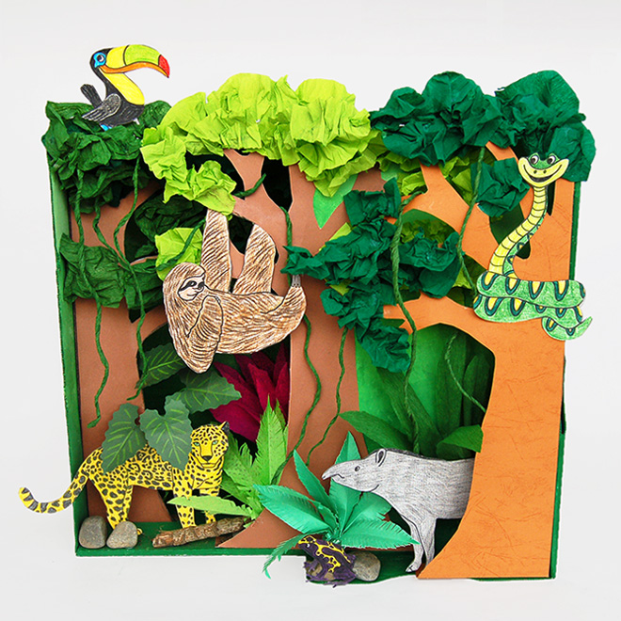 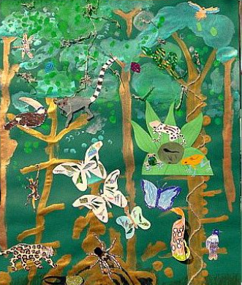

**Maths**

**Can you name and describe most common 2D and 3D shapes?**

Go on a shape hunt and make a list of all the shapes you can find. Try cutting out 2D shapes to make a picture, use some 3D shapes to make a junk model sculpture.

*\*see attached sheets to help with vocabulary*

Roaming the Rainforest

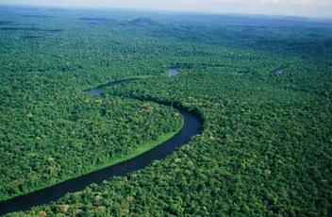

**What is a Rainforest habitat?**

<https://www.bbc.co.uk/bitesize/topics/zx882hv/articles/zxdsvcw>

**English**

**Watch/read and discuss the story The Great Kapok Tree again**

<https://www.youtube.com/watch?v=J1Teb-_jTyI>

Now discuss and write your own ending to the story.

**Skylarks’**

**Home Learning ☺  
Week 4**