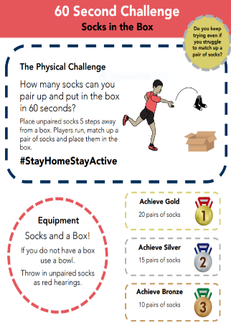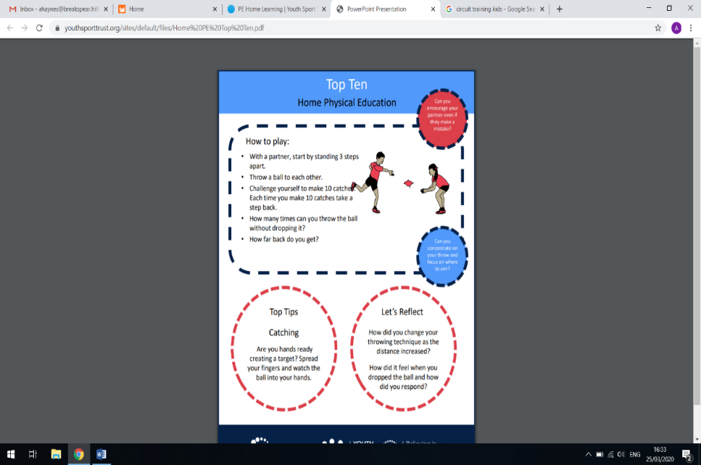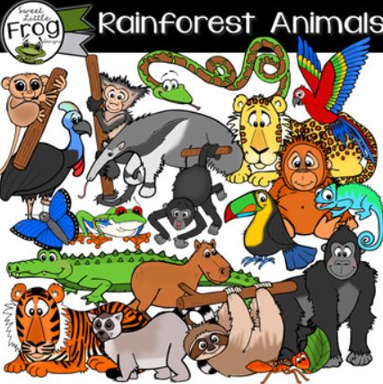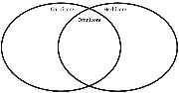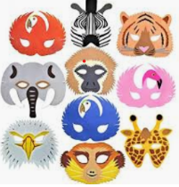

Roaming the Rainforest

Carnivore, omnivore and herbivores

<https://www.youtube.com/watch?v=oCFU3tLdjRY>

**Science**

Find out what animals like to eat. What do the terms carnivore, omnivore and herbivore mean?

Can you sort the animals into sets using the ideas attached?

**PE**

**Top Ten and 60 second challenge**

**Maths Fractions of shapes**

Find things you can cut into halves and quarters and even thirds, e.g a pizza, a cake, an apple or a slice of toast.

Ask your grown up to draw some shapes on a page. Can you split them into halves, quarters or thirds?

Link to video on fractions of shapes:

<https://www.youtube.com/watch?v=6ooKWyPI0i4>

**PHSE** 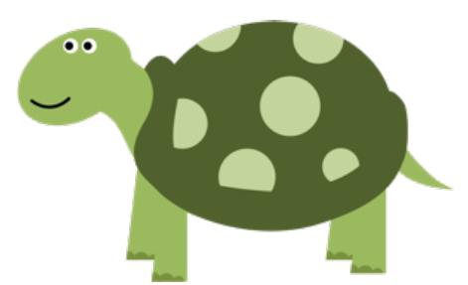

Living through Lockdown – all about me!

Read, discuss and complete the ideas and activities on the attached sheets

**Geography**



Finding out about Brazil

Read and discuss the information and issues facing Brazil today using the fact sheet attached.

Can you find out any more about Brazil?

Try the Brazil Quiz PowerPoint attached

**English**

Write out your own

information fact sheet all

about Brazil.

**Skylarks’**

**Home Learning ☺  
Week 5**

**Art/D. T**

Make your very own Rainforest

Animal mask