Viking Raid on Lindisfarne (793 AD)

On the 6th of June 793 AD, 'Northmen' (as the Anglo-Saxon Chronicle calls them) attacked the Christian monastery at Lindisfarne in Northumbria. The monastery was on a small island off the coast called Holy Island, making it an easy target for the Viking longships.

Northumbria was an English kingdom, and its unprotected monasteries were famous for expensive books, art and treasures. It was this attack that made people realise how dangerous the Vikings were.

The first few months of the year 793 AD were worrying times. Anglo-Saxon writers in north England wrote about how ‘immense whirlwinds, flashes of lightning and fiery dragons were seen flying in the air’. They thought this weather was a sign of danger to come.

This Viking raid on Holy Island, just off the Northumbrian coast, was not the first in England. But the raid on Lindisfarne monastery was different because it attacked ‘the very place where the Christian religion began in our nation’. It was where Saint Cuthbert had been bishop, and where his body was buried in 687 AD.

Alcuin, an Anglo-Saxon man in Northumbria, wrote that:
“The church of St Cuthbert is spattered with the blood of the priests of God, stripped of all its treasures, and left unprotected from these plundering pagans.”

Alcuin calls the Vikings pagans because they were not Christian like the Anglo-Saxons were. The Vikings believed in many different gods who had different purposes, e.g. Thor was the god of war. The Vikings therefore had no respect for the Christian monastery or its monks.

The Vikings travelled to England on wooden longships. These were fast, streamlined boats that were powered by paddles. They were light enough to be carried over land, and could turn direction quickly.

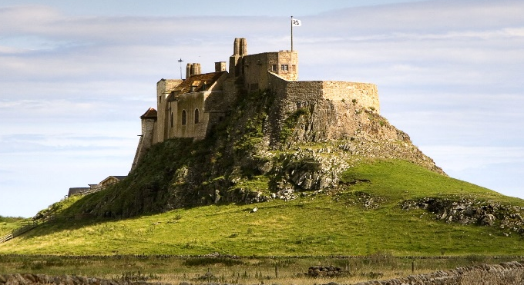
They burned buildings, stole treasures, murdered monks, and terrified everyone. Some Anglo-Saxon Christian leaders said God had sent the Vikings, to punish people in England for their sins. Alcuin was particularly worried about why God had allowed such a holy place to be attacked: “Is this the outcome of the sins of those who live there?” he asked, wondering if the monks had disobeyed God.

The Vikings did not send many ships on their first raids. They made surprise attacks on unprotected places, like Lindisfarne. They knew they would not have to fight a big Anglo-Saxon army. Saxon kings were too busy fighting each another to join forces against the Vikings. There was no English navy to guard the coasts, so it was easy for Vikings to land on a beach or sail up a river.

The Vikings fought using long swords and axes. Vikings did not wear much armour, though some wore chain mail coats, and most relied on a round wooden shield for protection. On their heads, they wore helmets made of leather or iron. The monks had no weapons and no warriors of their own to protect them against the Viking raiders.
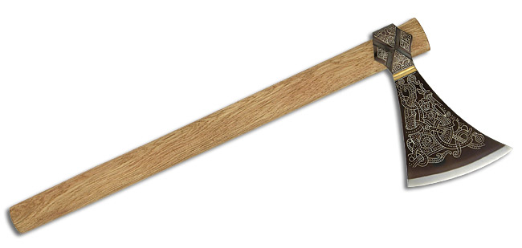

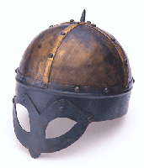

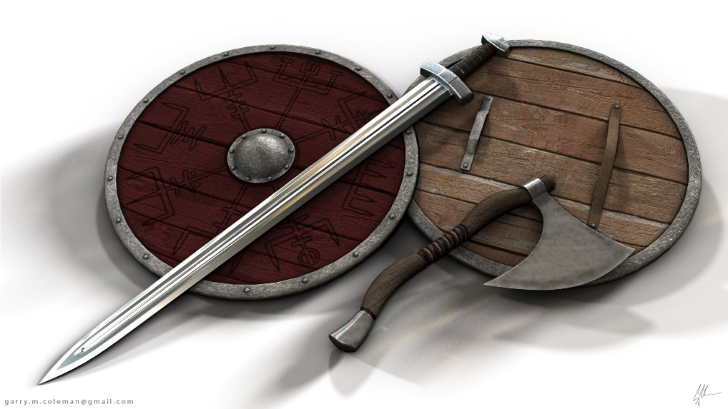

Monk Simeon, an Anglo-Saxon monk in Durham, wrote that:

“On the sixth of June, they reached the church of Lindisfarne, where they miserably ravaged and pillaged everything; they trod the holy things under their polluted feet and plundered all the treasures of the church. Some of the monks they killed, some they carried off in chains, most of them they stripped naked, insulted, and cast out of the doors, and some they even drowned in the sea.”

After raiding the monastery, the ships sailed home with their new treasures and slaves. The parts of the monastery that were made of wood were burned down before they left.

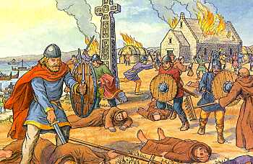

Questions:

- Why did the Anglo-Saxons think something bad was going to happen in 793 AD?

- When did the Viking raid on Lindisfarne happen?

- Why were the Vikings able to beat the monks in the monastery so easily? (Give 2 reasons)

- Why did the Vikings have no respect for the monastery?

- Who did Alcuin blame for the attack? Why did he say this?

- What did the Vikings do to the monks?

- Can you trust what Monk Simeon and Alcuin wrote as being the truth? Give reasons for yes and no.

Viking’s view

The monastery at Lindisfarne was a perfect place for us to raid. Situated off the coast of Northumbria it was an island really, only accessible from the mainland at low tide. We decided to attack at high tide so no one could come to the aid of the monks who lived there. We had been watching the monastery for a long time so we knew how many men were inside and working there. We knew which buildings were the most important, you know, the ones where all the gold and silver was kept. We planned it well. Every warrior had his task. The crew was split, some stayed with our long ship to ensure it was it ready to sail, the rest joined us on the raid. I know most people think we just sailed across the North Sea and landed at Lindisfarne, but that wasn’t the case. We had sailed down from the Shetland Islands and landed just up the coast from the monastery, watching and waiting for the conditions to be right. Waiting for our adventure to begin, oh and what an adventure it was!

Monk’s view

I’m brother Cuthbert, one of the few monks to survive the attack on St Cuthbert’s church on the Holy Island, Lindisfarne in the year 793AD. It was such a peaceful place, the only sounds were that of the sea, our church bell and the gulls, but the assault upon our gentle lives was so sudden and brutal. I was tending to the vegetable garden, when I heard the war horns and angry yells, then I heard screaming. I stepped out to see what all the commotion was about and was so shocked at what I saw that I simply froze with absolute terror. My brothers, the monks whom I knew and loved as dear friends, were being hacked to pieces with axes and swords in front of me. The men attacking were laughing as they carried out their slaughter. You might wonder how I survived, well I managed to recover from my shock and ran. I hid in some bushes away from the buildings and I watched as the older brothers were slain and the younger ones bound and led away, together with all our treasures. It seemed to me that the raid had been well organised.

