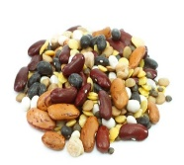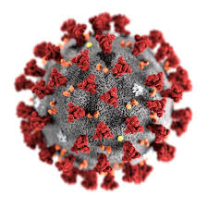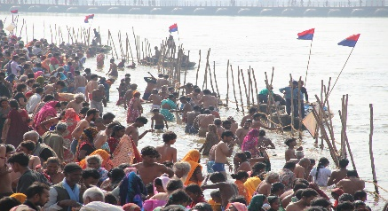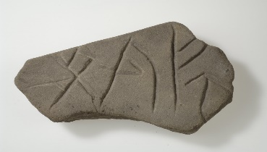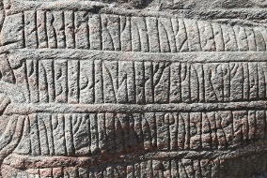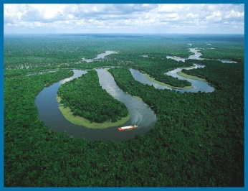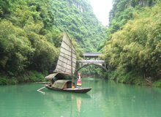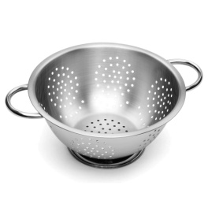

Vikings Week 7

**Maths**

Solve the Rune Code.

Plan a party for your Friends. You Have £100 to spend! (See separate Sheets.)

Practice your Tables!

**Science**  Separating mixtures

Look at the power-point and describe the different processes in your own words. Can you have a go at the experiment? You might have to adapt it depending what you have in your cupboards!

 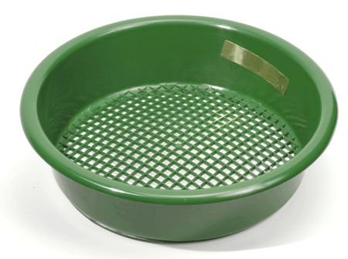

PSHE

Make a Health and Safety Poster, explaining facts about Covid 19 and the steps needed to be taken to keep yourself and others safe. Make it eye-caching and informative.

**R.E.** Why is the River Ganges so important to Hindus? Why do they think it is sacred? What is it used for?

<https://www.learnreligions.com/ganga-goddess-of-the-holy-river-1770295>

<https://www.webpages.uidaho.edu/~rfrey/116ganges.htm>

History

Find out about Viking Writing.

Can you see the differences between the Anglo-Saxon alphabet and the Viking’s?

Write some messages in Runes

**Geography** -2 week project

Reseach to find out about Rivers of the World. Try to write about a river from each continent. Some examples are Amazon, Murray, Thames, Nile, Volga, Yangtze, Seine, Rhine etc

Can you find the answers to the questions in this quiz? <https://www.wanderlust.co.uk/competitions/rivers-of-the-world-quiz/>

**English**

Complete: Rivers of the World Comprehension.

Write a set of instructions for how to make a Viking longboat or a Viking recipe.

Remember how to set your work out correctly and think what you need to include (see help sheet.)