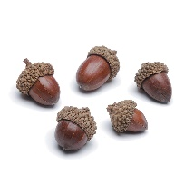

R.E

Find out about Hindu’s beliefs about Karma and Reincarnation.

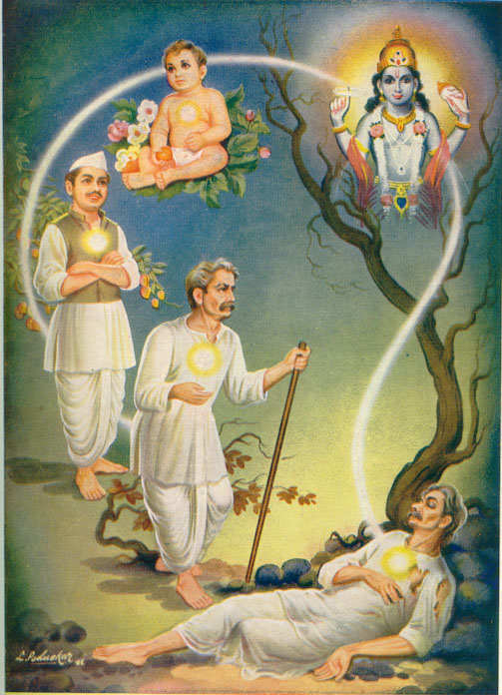 Vikings

English (Do your History work first.) Write a newspaper report about the raid on Lindisfarne. Remember you are writing as if it has just happened. Think about you Headline and subheading- do they sum up the story? Remember your first paragraph should tell you who, what, where and when.

Your second paragraph gives more detail and information. You need eyewitness accounts to move the story along. (Don’t just repeat what you have already said.) Sum up in your conclusion.

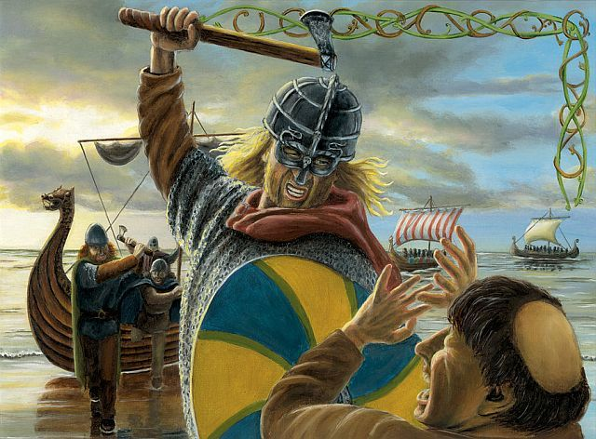

Maths

This week you have 2 Outdoor Maths Challenges- see separate sheet.

Don’t forget to take a photo of your work.

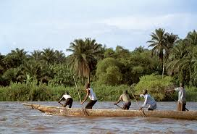

Vikings Week 8

Science Thermal conductivity

Watch the Power-point. What are insulators and conductors of heat?

Can you plan an experiment to test which materials are the best insulators? How will you make your experiment fair? With an adult, can you try your experiment out? Don’t forget to make predictions first. 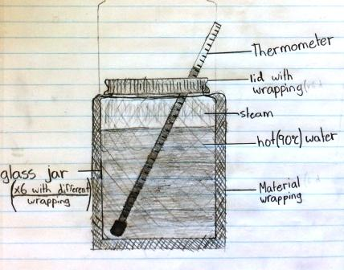

GEOGRAPHY

Continue your Rivers Project.

You may like to make a

Power-point Presentation.

Art

Have fun. Sketch, Paint, collage anything you see from your window. Can you find a painting of a window scene by a famous artist?

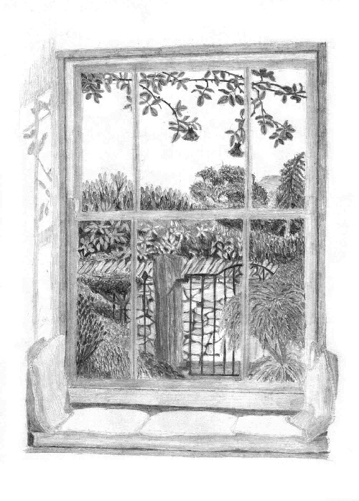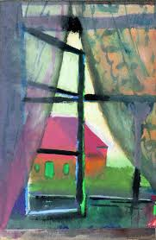

History

Watch the video, read the help sheet and answer the questions about the Viking Raid on Lindisfarne. 