English:

A kenning is a type of Saxon or Viking Poem. They are like riddles, which describe something without saying what it is. Each line has only two words. These words are joined using a hyphen. The two words are usually a noun and a verb. We use kennings in our everyday language, such as 'sky-scraper.' The Vikings used Kennings to describe their swords e.g. death-bringer.

Have a go at writing your own kenning about a Viking. ( See Powerpoint and Border page)

R.E.

<https://www.youtube.com/watch?v=0_OBq865VjI>

Draw a story board showing the Christian Creation Story.

Art Create Your own Norse god or goddess. Think about depicting their special power.

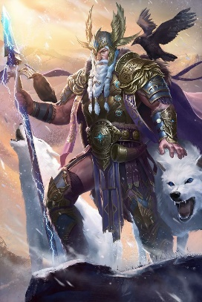

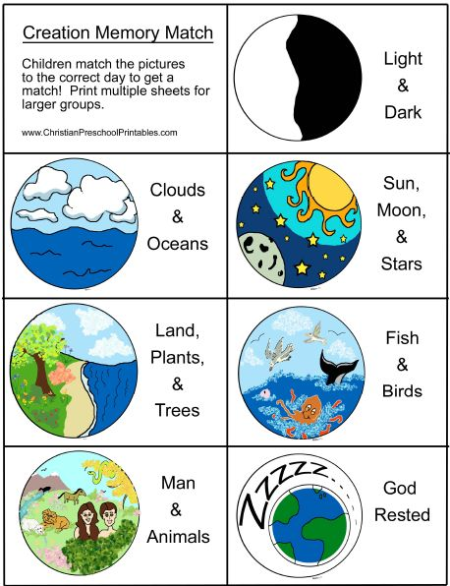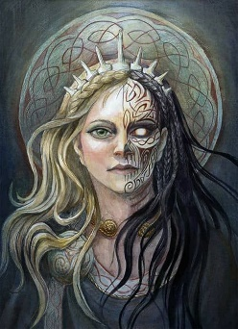

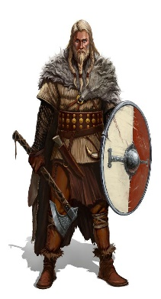

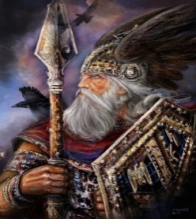

GEOGRAPHY

Go for a walk (with an adult)

along the River Waveney and fill in the field study sheet.

History

Find out about Viking gods and goddesses. Then make a set of Top Trump cards. Have fun playing the the game.

( All resources and instructions on how to play are included.)

Vikings

Week 9

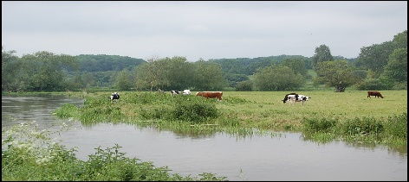

Science

Find out about the parts of a plant. Draw a diagram and label it (or use worksheet.) Watch the video: <https://www.bbc.co.uk/bitesize/topics/zgssgk7/articles/zyv3jty>

Describe the process of pollination. (See worksheet.)

Maths

You have some more work on finding averages this week, linked to Viking gods.

Can you also write a ‘Top Tip’ explaining to another child how to find the range mode, median and mean?

There is also a coordinates activity. Remember the rule; ‘Along the corridor and up the stairs.’

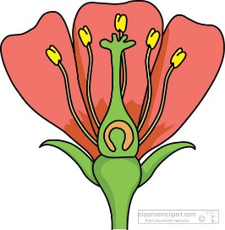

Transition Y6 only

Look at the website for your new school.

Find out the school logo, how many children are there, the uniform you will need and the subjects that are taught.