St. Cuthbert’s Chronical

9th June 787 AD
Price : 1 Grote
YOUR DAILY FAVOURITE NEWSPAPER
Lindisfarne Lost !

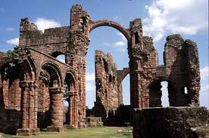
The fierce heathen horde, having first rounded up any livestock from around the monastry, proceeded to invade the ancient and holy building itself.
Filled with the accumulated wealth of the order, the ruthless raiders plundered all that they could. Seizing precious and irreplaceable religious artifacts, England’s most holy of sites has been left bereft of all that it held dear.
Not content with stealing as much gold and silver as they could carry, the Vikings then turned their evil eye to the monks themselves. Those that were not kidnapped, were held hostage: others were shown no mercy and were brutally slaughtered where they stood. One surviver- who wishes to remain annoymous- recalled that St. Cuthbert’s church lay spattered with the blood of his fellow priests. ”We’ve lost everything!” he said before adding how deeply saddened he was that such a venerated place as St. Cuthbert’s should fall into the hands of pagens.
These sentiments will be echoed throughout the religious communities of Britian; many monasteries now fearing that this may only be the first of many attacks from the savage Scandanavian scurge.
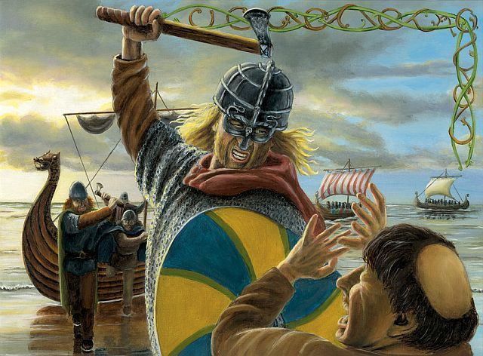

England’s most holy monastry - Lindisfarne in ruins.
Distressing news has reached the mainland of a most terrifying and unprovoked attack on the monks of St. Cuthbert’s monastry on Lindisfarne.
Yesterday, during the early hours, eye- witnesses (who were fortunate to survive and escape the slaughter) reported sightings of strange wooden ships emmerging from the eerie sea mist. Brother Peter, who narrowly escaped being slaughtered, described them as appearing like demons from the mouth of hell. ’’We was really terrified we was and tried our best to get away from em. But there was no stoppin’ em,” he said.
The priests of Lindisfarne are men of peace and learning: the monks were completely unprepared for what was to befall them. Having landed their ships, the Viking raiders wasted no time in over-running the unprotected island.

Olaf of Ainsdale

