Ancient Runes Here is a table containing all the letters of the alphabet:
Alphabet
A | B | C | D | E
F | G | H | I | J
K | L | M | N | O
P | Q | R | S | T
U | V | W | X | Y
Z
It has six rows (going from left to right) and five columns (going from top to bottom). The Vikings communicated in writing by making simple scratches on wood or stones called runes. Sometimes they were written in a secret or coded way. Here is 'was' written in code.
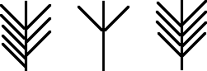
Can you work out how the code works using the table of the alphabet?
Here is a message in secret runes:
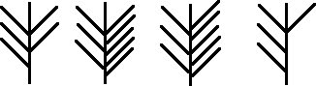
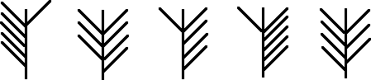
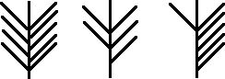
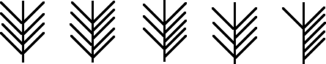
Can you decipher it?
Perhaps you can make up your own message. Each symbol has a line drawn vertically (from top to bottom).
Tip : Can you see a connection between the number of lines drawn off the left of this vertical line and the row where the letter is in the table?
Perhaps there is a similar connection between the lines off the right and the column position?

