Phonics

Please see Tapestry for your daily phonics session. In the meantime, keep practising by watching Alphablocks on CBeebies iPlayer.

Literacy

Read ‘Jake’s First Day’ attached as a PowerPoint.

Complete the ‘All about me’ booklet (attached) for Mrs Ward and Mrs Rix.

Complete the Goodbye Reception sheet (attached).

Also attached are some pirate colouring pages and a pirate word search if you’d like to have a go.

Personal, Social and Emotional Development

What might it be like in next year in Skylarks class? How might it be different to Sparrows? How will it be similar?

What are you looking forward to about being in Year 1?

Do you have any worries about going into Year 1? Talk about these with a grown up. If you have any questions, please ask them on Tapestry and we can answer them for you.

Physical Development

Andy’s Wild Workout – Cbeebies iPlayer

Cosmic Kids Yoga – YouTube

PE with Joe – YouTube

Fine Motor Skills Activity

School Uniform Challenge: Can you get dressed into your uniform independently, eg doing up the buttons, zips, buckles, socks and shoes etc.?

How quickly can you do it?

Maths: Time

Time – sequencing events in the day. Draw a poster showing the sequence of your day (e.g get up, get dressed, brush teeth, lunch etc). Talk with an adult about what time of day you do these different activities. Use language of time such as “first, after, next, morning, afternoon, night” to describe your routine to another family member. Try and label your poster with some time language.

Can you guess how long a minute is? Try to sit in silence for one whole minute. Did you guess correctly when a minute had passed?

What jobs can you get done in 5 minutes? Example how many toys can you pick up and tidy away in 5 minutes? Practise each day see if you can increase your score each time.

Visit the link below to listen to the song about telling the time**.** [**https://www.bbc.co.uk/teach/supermovers/ks1-maths-telling-the-time/zk4t8xs**](https://www.bbc.co.uk/teach/supermovers/ks1-maths-telling-the-time/zk4t8xs)

**Change - What’s Next?**

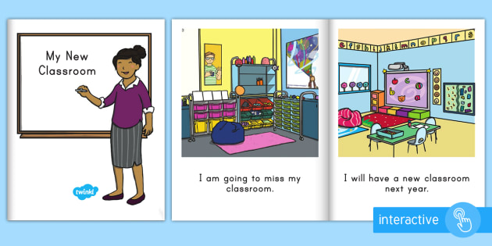

**Home Learning – Sparrows**

**Week Eleven**

Expressive Arts and Design

Paint a picture of my new teacher or teaching assistant

Draw my new classroom