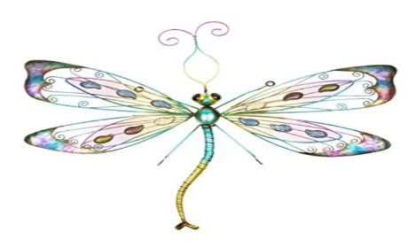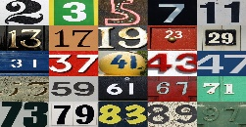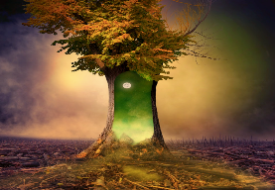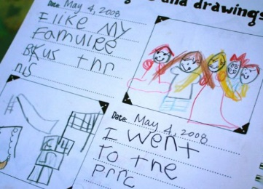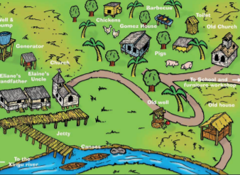

Roaming the Rainforest

Green plants and animals of the rainforest

<https://www.bbc.co.uk/bitesize/clips/zb2jmp3>

**Art/D. T**

**Art outdoors-**

**make a collection of natural objects to turn into a /pattern/picture or sculpture**

See *attached* sheets for ideas

**Science**

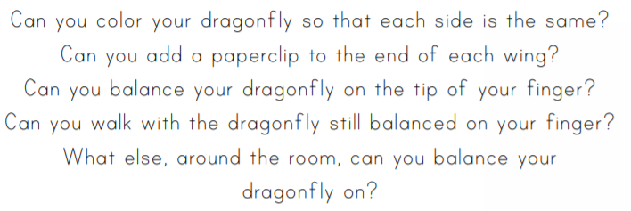

See *attached* sheets for template and instructions

**PE**

Balance Time and 60 second challenge See *attached* sheets 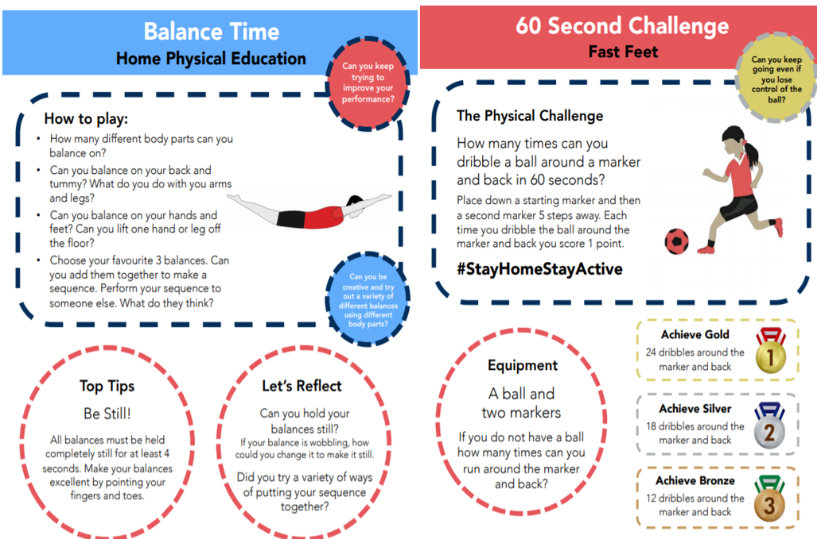

**Maths Place value**

Play the ‘Guess my Number’ place value game. Make sets of numbers to 10/20/50 or 100

Link to ‘Guess my Number’ video played with 3 digit numbers but choose numbers to 10/20/50 depending on ability

<https://www.youtube.com/watch?v=wzvQ5R-A0Bk&list=PLWIJ2KbiNEyoBDc5yLJ4PaiaY3o5E5xCB&index>

**PHSE**

Use this week to write and illustrate a ‘last week of lock down journal’.

Ideas to include:

-Three things you want to do

-News-what did you eat/drink/who were you with/who did you speak to?

-Things that are good in your life

-I feel happy/sad when…

- Favourite memory

**English**

**The magic tree part 2**

**Please see *attached* sheets for instructions –**

**Story time!**

**Geography**

**Directional language and map skills.**

**Use the activity sheets *attached* or make your own using the sheets and ideas as a starting point.**

**Skylarks’**

**Home Learning ☺  
Week 7**