Writing Home Learning for Skylarks
Look at this picture of The Magic Tree:
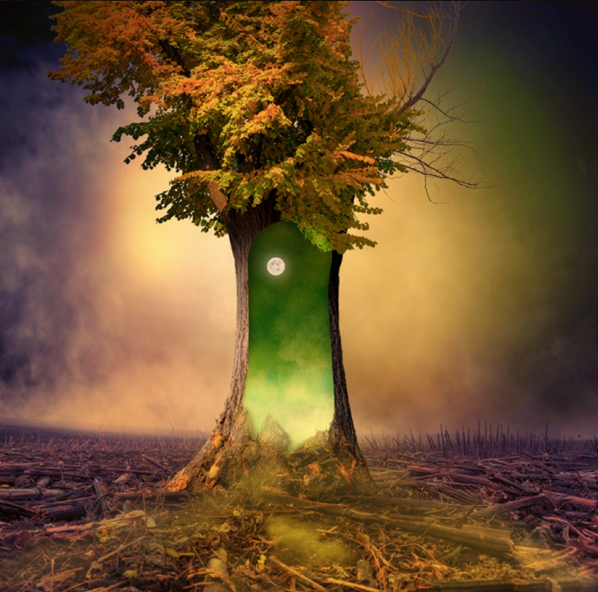
The tree was all that remained. A solitary figure, it stood there with destruction surrounding it. The bark had begun to peel away, one piece at a time, joining the wreckage of other trees that lay scattered across the scorched earth. This tree was different from the other trees. It contained magic. It contained hope…

Task 1:

Discussion time with an adult!
What do you think has caused the destruction all around the tree?
Why has this one tree survived?
If you walked through the portal, what would happen to you? What would you see?
If this portal to another world, would you go through it or stay on Earth, even if you had no idea what could happen?

Is it good to take risks? Are some risks riskier than others?
Task 2:

Perfect picture!
Imagine you have just walked through the open portal and into the world inside the tree. Draw/describe what you can see. Use adjectives (describing words)
Task 3:

The Magic Tree
Can you continue the story? What is so different about this tree? What has happened to the other trees around it? Who discovers it? What happens to them? Do they end up in another world? How do they get home?
You could make your story or sentences into a mini book with illustrations… Be creative!

