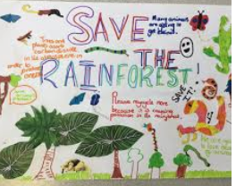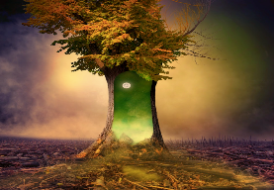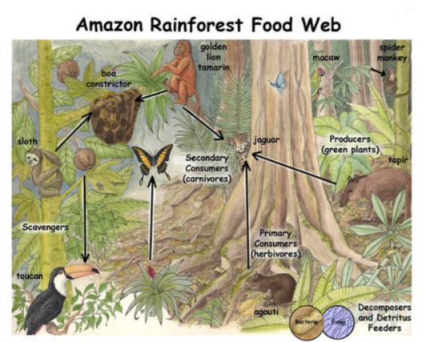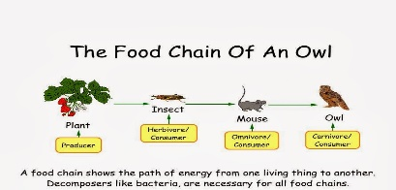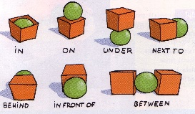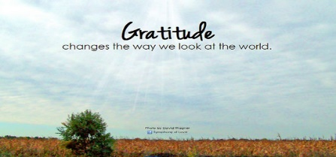

**English**

**The magic tree**

**Please see *attached* sheets for instructions – this activity will be over the next two weeks. Start with the reading & discussion**

**Art/D. T**

**Go on a virtual visit to an exhibition of famous jungle paintings!**

**Click on the link and then on the first painting to scroll through.** <https://www.artranked.com/topic/Famous+Jungle>

**Discuss your thoughts on each picture with an adult**

**Geography**

**Make a Save the Rainforest poster- include some ways to do this or organisations that help.**

**Science**

What is a Food chain? Have a look at the food chain pyramid *attached* and discuss. Can you draw a food chain with 3 things and arrows to show where the energy is transferred?

<https://www.bbc.co.uk/bitesize/clips/z8hxpv4>

**PE**

This week, practise some Yoga positions!

Please see *attached* pictures for positions to try.

**Maths** Position/Direction & movement

Practice moving and turning your bodies or toys

Left/right/up/down/forwards/backwards/between/under/on top

Use the *attached* sheets for ideas to give and follow directions

<https://www.bbc.co.uk/teach/supermovers/ks1-maths-position-&-direction/zhh9scw>

Roaming the Rainforest

**PHSE**

**What does being grateful mean?**

**What are you grateful for today?**

**Draw a picture and write a sentence for 3 things that you are grateful for today.**

**Skylarks’**

**Home Learning ☺  
Week 6**