
Ellingham VC Primary School
Church Road,
Ellingham,
Bungay,
NR35 2PZ
Tel: 01508 518250
office@ellingham.norfolk.sch.uk

Headteacher: Miss Dawn Read
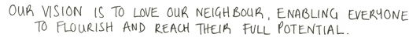
John Chapter 10 Verse 27

2022

Dear Parents/Carers,

Our walking bus runs on a Tuesday, Wednesday and Thursday. We meet at the Olive Tree car park at 8.15 am and the children will walk to school supervised by at least 2 adults. Year 6 children will be there to hold the hands of younger children. All adults and children will wear a high visibility tabard, and a risk assessment has been carried out.

Please note that the Olive Tree is not to be used as a car park for your cars. The idea is that you walk to the Olive Tree to meet the walking bus. If you need to drive to the village first, you may use the Olive Tree Car Park to pull into, slowly, to drop off your child.

Please complete the reply slip below if you would like your child to take part in the walking bus.

Yours Sincerely

Miss Read
Headteacher
…………………………………………………………………………………………………………………………………………………………………...

I would like my child to attend the walking bus on the following days (Please delete as appropriate) Tuesday, Wednesday, Thursday.

Name……………………………………………………………… Class…………………………………………………………

Signed………………………………………………………………………………………………………………(Parent/Carer)



