**English**

Create a passport for our journey to Africa. There are templates on Twinkl, but you can just use a piece of paper. What information do you need to include?

Daily reading, remember to

use Oxford Owl for free books.

Phonics

Teach Your Monster to Read

Year 1 – Phase 5 games on Phonics Play

Receptions – Phase 2 and 3 games on Phonics Play

**Willows**

**Home Learning   
Week 1**

**Science**

Can you draw and name an animal for each of these categories?

Bird/fish/mammal/amphibian/ reptile

Can you label the parts? (beak/ feather/fur/4 legs/2 legs etc)

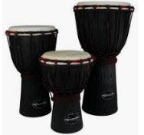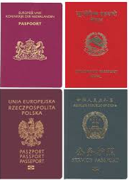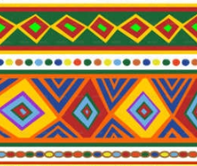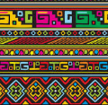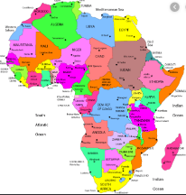

**Music**

Can you listen to some African drum music? Can you make an African drum?

**Art**

African patterns

Can you research and design your own African patterns?

**Maths**

Daily Maths Whizz (30 minutes)

Daily practise counting in 2/3/5/10. Can you write multiplication number sentences?

Can you make your own number sentences using the < > and = symbols? Remember, the crocodile eats the big number!

Using the number line attached, roll 2 dice and make a 2 digit number, write it on the number line. If you haven’t got dice, you can use this online dice <https://www.online-stopwatch.com/chance-games/roll-a-dice/>

Receptions

Can you write your numbers to 20?

Can you find 10 objects in your house (buttons, sweets, Lego bricks) How many ways can you partition them? E.g. 1+9=10, 2+8=10. Can you find 20 objects?

**P.E.** Use Joe Wicks live PE session.

<https://www.youtube.com/channel/UCAxW1XT0iEJo0TYlRfn6rYQ>

**Computing**

Use the scratch link on the school website.

We’re Going on Safari

**Geography**

<https://www.twinkl.co.uk/resource/cbeebies-go-jetters-continent-of-africa-powerpoint-t-g-642>

Can you draw a map of the world and label the continent of Africa?

How many countries are there in Africa?