**Willows**

**Home Learning   
Week 2**

**English**

What are the features of a letter? Look at some letters online, what do they need?

Can you write a letter to an imaginary person in Africa telling them about what your house is like, what your local area is like, what the weather is like and what you like to do.

Daily reading, remember to

use Oxford Owl for free books.

Phonics

Teach Your Monster to Read

Year 1 – Phase 5 games on Phonics Play

Receptions – Phase 2 and 3 games on Phonics Play

**Science**

There are 4 types of habitat in Africa, mountain, desert, grassland and rainforest. Can you research each type of habitat, draw a picture of it and write about it in your book?

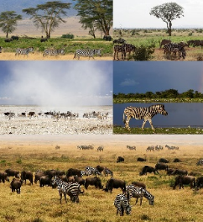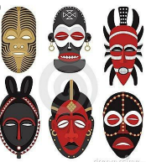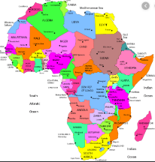

**P.E.** Use Joe Wicks live PE session.

<https://www.youtube.com/channel/UCAxW1XT0iEJo0TYlRfn6rYQ>

**Maths**

Daily Maths Whizz (30 minutes)

Daily practise counting in 2/3/5/10. Can you write multiplication number sentences?

Receptions, can you practise your counting and writing your numbers everyday.

Year 2 we are learning about fractions

Each day I would like you to watch one of the videos from Week 1 and then answer the questions <https://whiterosemaths.com/homelearning/year-2/>

Year 1 and Receptions, we are learning about weight and mass

Each day I would like you to watch one of the videos and then Year 1 answer the questions, Receptions you can answer the questions too if you would like.

<https://whiterosemaths.com/homelearning/year-1/>

The videos can we watched on tablets if you don’t have a laptop, and if you don’t have a printer, just write the answers down in your books.

**Music**

Log on to Espresso and go to Key Stage 1 Music. Can you watch Anansi and the Music Maker and then create your own music. <https://central.espresso.co.uk/espresso/modules/t1_musical_stories/index.html?source=subject--KS1--Resource%20types>

**Art**

**African tribal masks**

Can you find out about African masks? There are some great examples on the internet. I would like you to create your own, take a photo of you in it and post it on Tapestry for me to see!

**Geography**

Can you research human and physical features of a landscape? In your books, can you split your paper in half and write human at the top of one and physical at the top of the other and then draw and label examples?

Receptions – 2 examples for each

Year 1 – 4 examples for each

Year 2 – 6 examples for each

**Computing**

Use the scratch link on the school website.

We’re Going on Safari