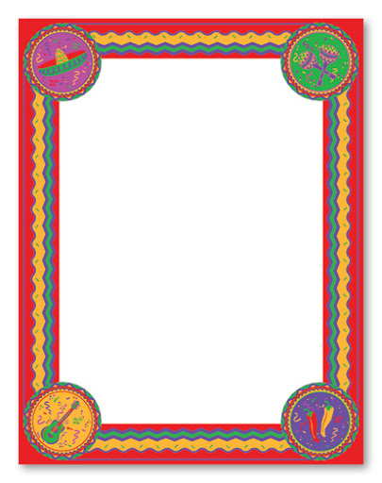

**MATHS:** Please complete 30-40 minutes of Maths Whizz each day.

Can you make a Mexican beanburger?

(recipe attached)

What are the main features of Mexican cooking? Add these to your fact file. 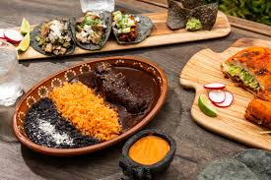

Can you make your own Mexican style salad?

Write out and illustrate your recipe.

Find and shade Mexico on the world map.

**Create a fact file on Mexico.**

Use an atlas or the internet to research:

* What continent is Mexico in?
* Can you shade the seven continents on your map?
* What countries are next to Mexico?
* What islands are near Mexico?
* What is the population of Mexico?
* What is the capital city?
* What is the highest mountain?

(See attached documents for blank map.)

**SCIENCE:**

Draw and colour a flower-what parts can you name?

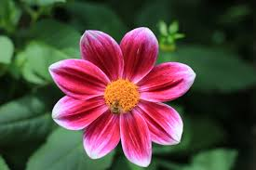

You have a flag of Mexico to colour in. What does the central picture symbolise? Add this information to your fact file. 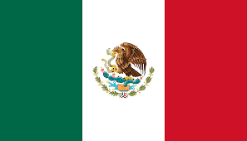

Poem:(see attached sheet)

**Following the Flight to the Fantasy Fair**: can you suggest names for the locations in the poem, or invent fantasy ones?

Can you create your own map which includes all the lands in the poem?