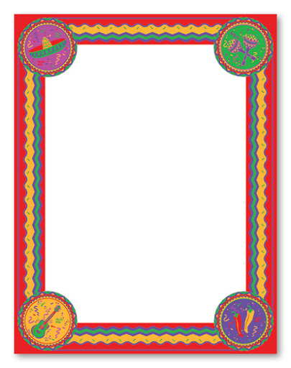

MATHS:
Grow your own tomatoes.
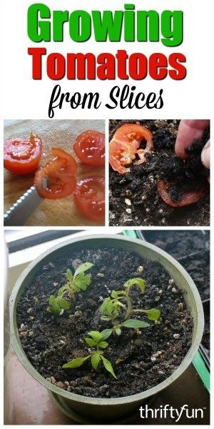
Keep a picture diary of their growth.
Mexican Pyramids
Make a fact file on the pyramids of Mexico.
How many pyramids are there in Mexico?
What is the tallest?
Can you make a pyramid? You could use Lego or cardboard.
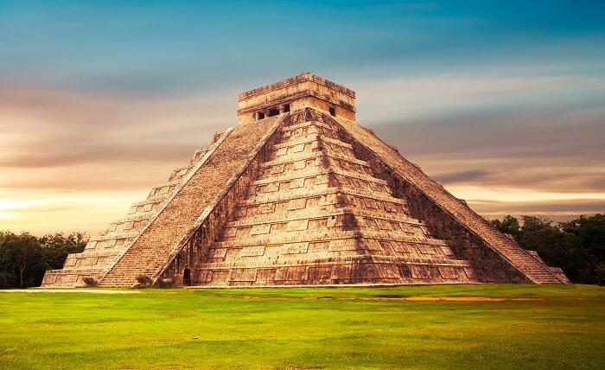
Please complete 30-40 minutes of Maths Whizz each day.
Mayan numbers:
Use the Mayan number system to create your own calculations.
Science: I spy tree leaves. Use this sheet to identify trees in your local area.
Poem:
Everything That Makes me Smile
List the things that make you smile.
Can you make them into a poem?
Can you illustrate your poem?
Can you learn the Spanish words for colours? Cut out and match from the sheet.

Art: Use the examples of Mexican patterns to design your own.
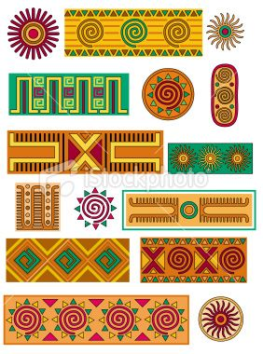
There are two levels of spellings to learn. One for lower KS2 and one for upper KS2,
Maya Creation story.
Read the story.
Can you answer the questions?
Write a comic strip of this story.

