Life Cycles Game

Game Instructions
Play this fun game with your friends or family to see how much you know about life cycles.
Who will be the first to construct the full life cycle?
You need:
- Life Cycles Game Character Cards cut out into individual cards
- Life Cycles Game Cards cut out into individual cards
How to play:
- Each player should take a character card. The aim of the game is to be the first player to construct the life cycle of the plant or animal on their character card.
- Shuffle the Life Cycles Game Cards and place them face down in a pile. The cards describe the stages of the different animals’ and plant’s life cycles.
- Players take turns to pick a card from the top of the pile. If the card describes a stage of their character’s life cycle, they keep the card. If not, the card should be returned to the bottom of the pile.
- As players collect more cards, they should place them in order to show the stages of their character’s life cycle.
- The winner is the player who constructs their life cycle first.
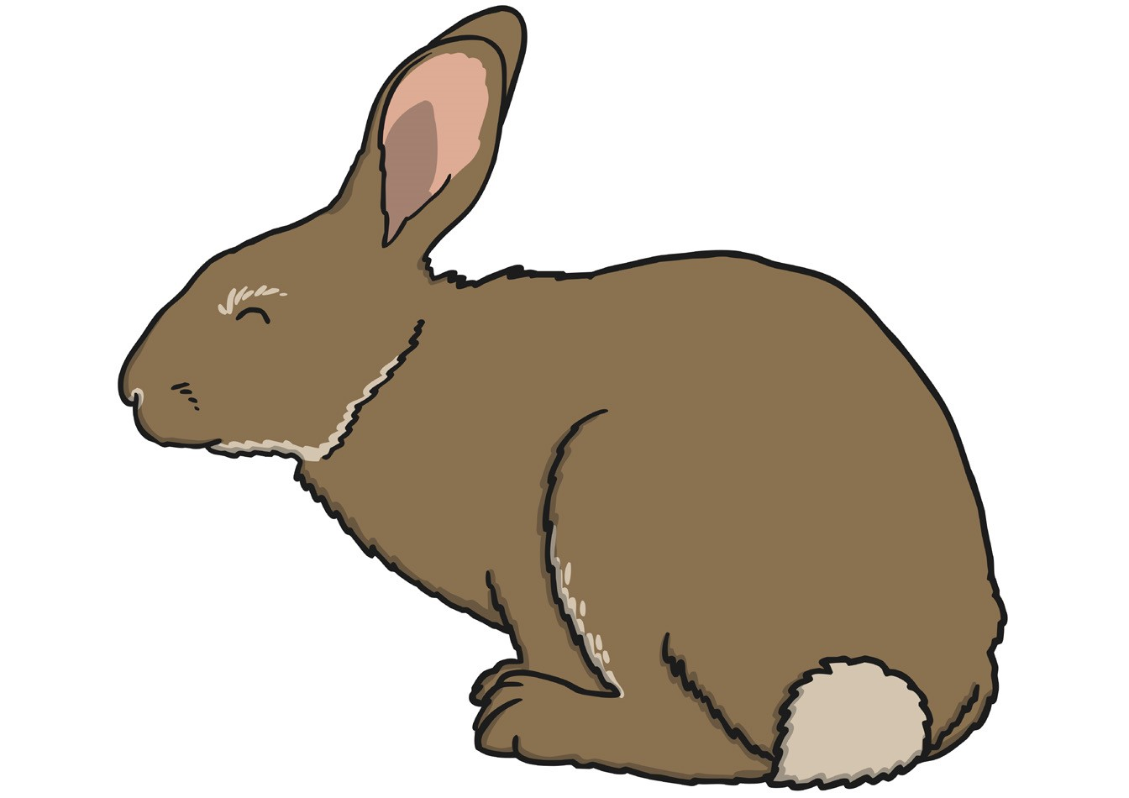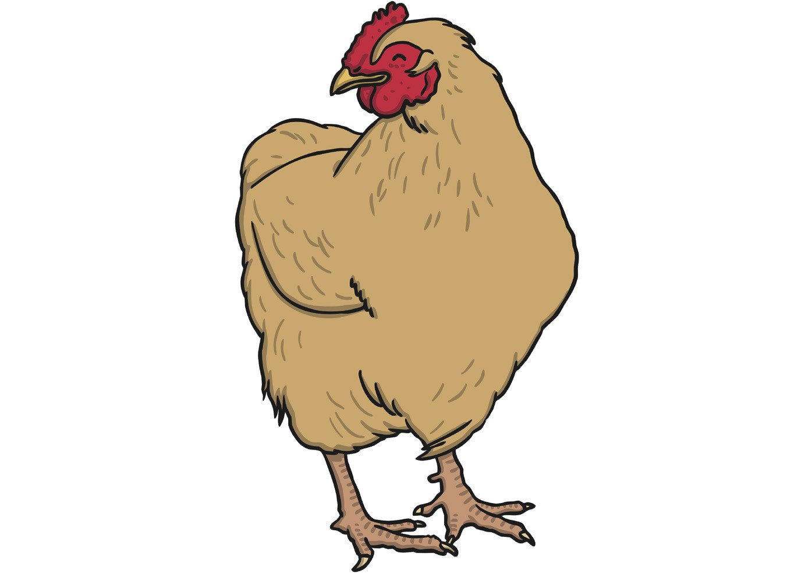
Character cards

Game cards
