Some plants are pollinated by the wind, and some plants are pollinated by insects. Cut out the pictures and statements and place them in the correct column according to whether they are about insect pollination or wind pollination.
flowers pollinated by the wind | flowers pollinated by insects
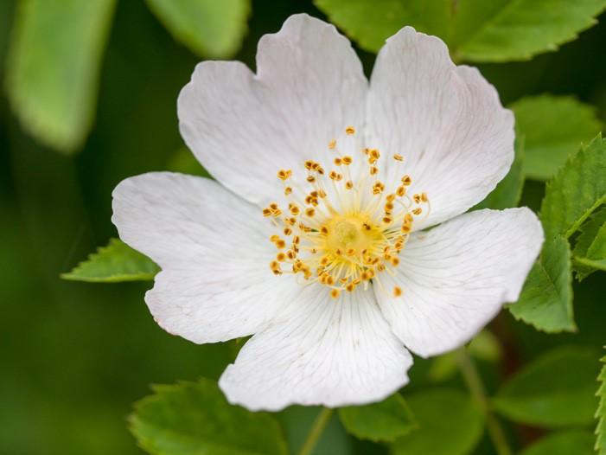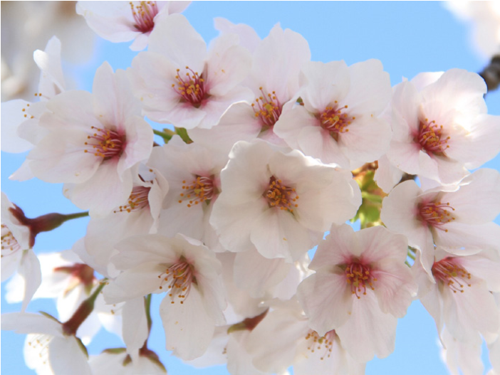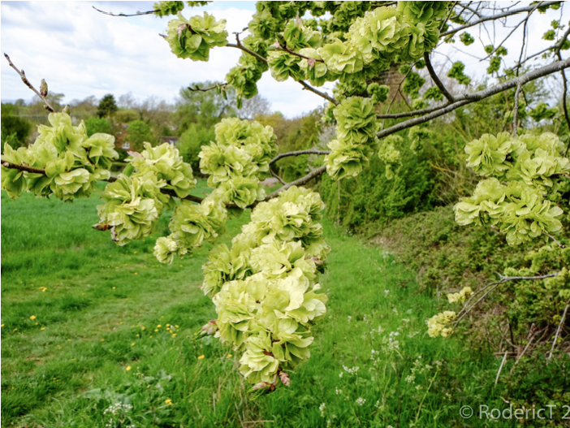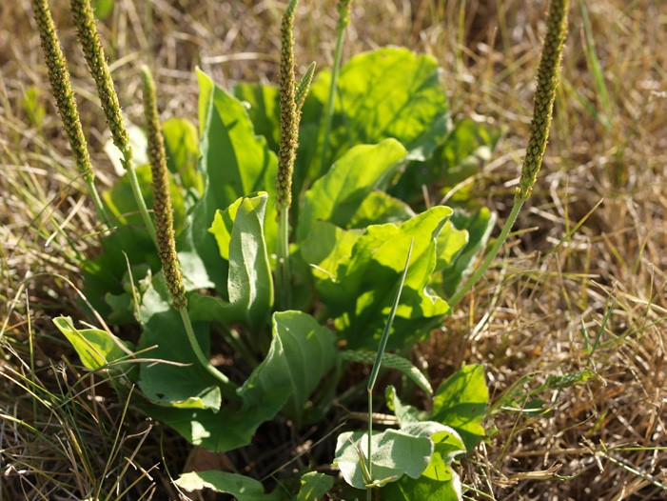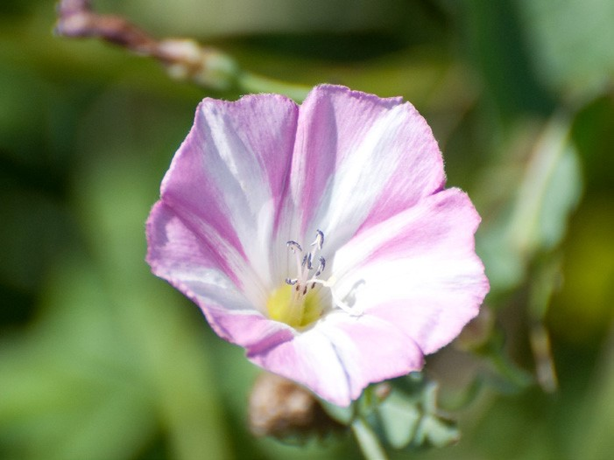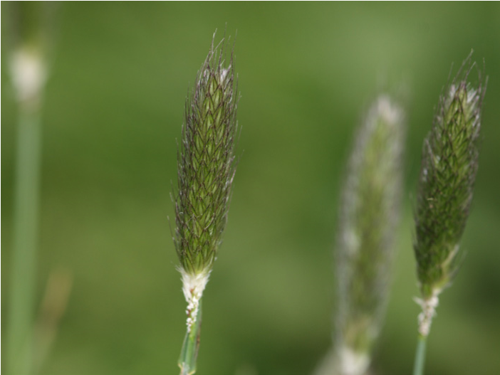
Brightly coloured so they look
attractive.
land on.
Have long, dangling anthers
that get blown around easily.
Have feathery stigmas to catch
pollen.
Have a strong scent so they
smell attractive.
Pollen is sticky so it attaches
easily.
Pollen grains are very small so
they blow around easily.
Stigma hangs outside the flower
so it can catch pollen grains.
dog rose
wych elm
bindweed
cherry
plantain
timothy grass
Some plants are pollinated by the wind, and some plants are pollinated by insects. Cut out the pictures and statements and place them in the correct column according to whether they are about insect pollination or wind pollination.
flowers pollinated by the wind | flowers pollinated by insects
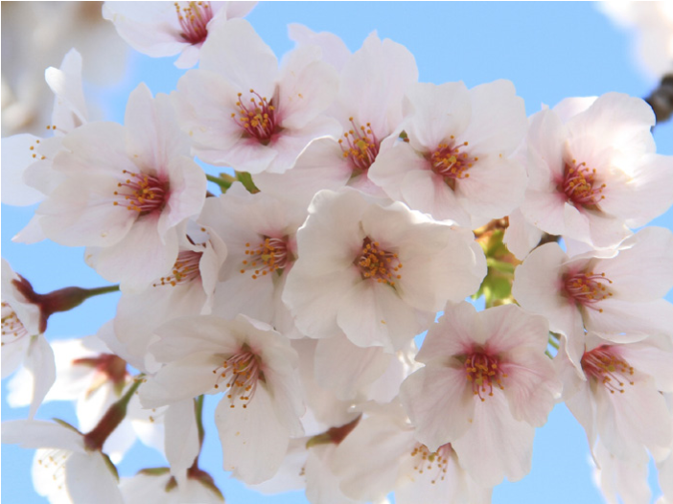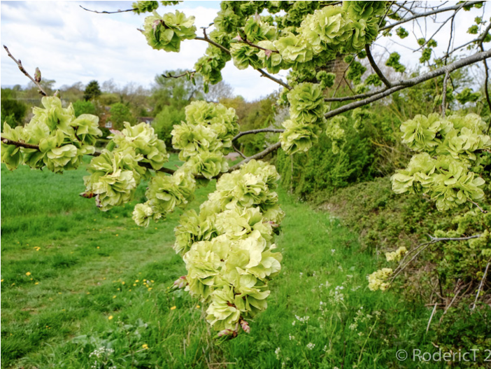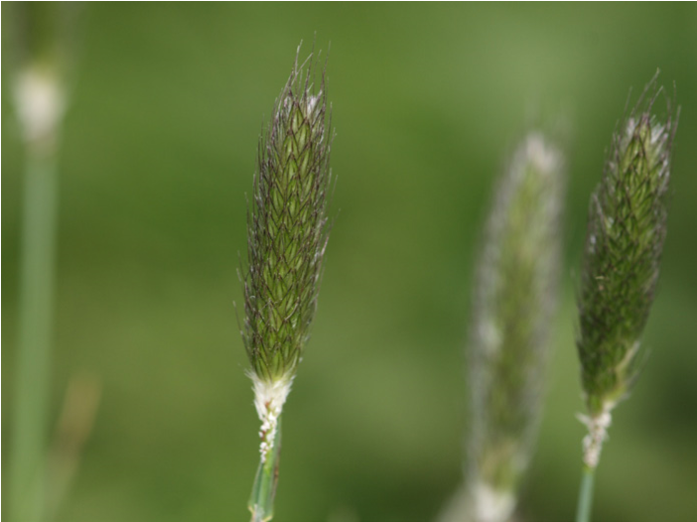
Brightly coloured so they look
_________________ .
land on.
Have long, dangling anthers
that get blown around easily.
Have feathery stigmas to catch
pollen.
Have a strong scent so they
________________________ .
Pollen is sticky so it
_______________________ .
Pollen grains are very small so
they _____________________ .
Stigma hangs outside the flower
so it can catch pollen grains.
dog rose
wych elm
bindweed
cherry
plantain
timothy grass
Some plants are pollinated by the wind, and some plants are pollinated by insects. Cut out the pictures and statements and place them in the correct column according to whether they are about insect pollination or wind pollination. Can you come up with some statements to fill the blanks?
flowers pollinated by the wind | flowers pollinated by insects
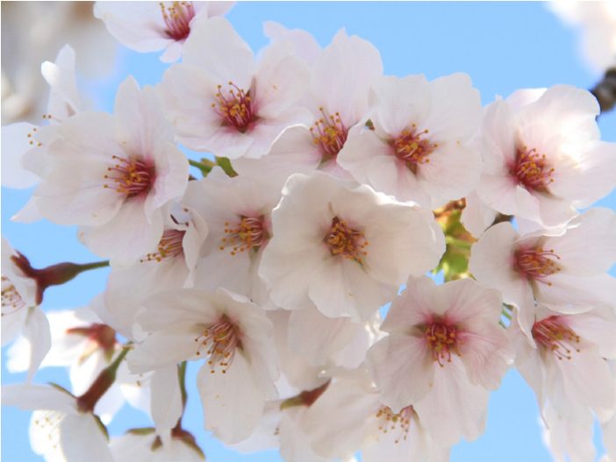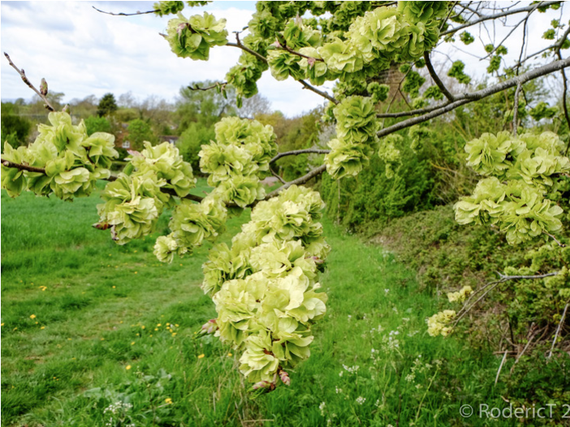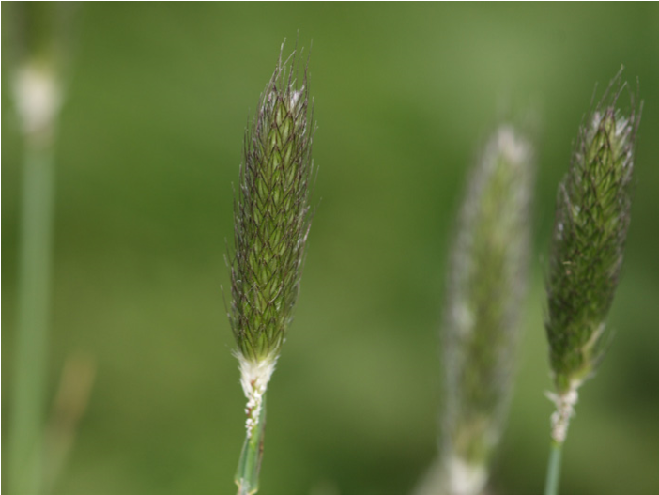
land on.
Have long, dangling anthers
that get blown around easily.
Have feathery stigmas to catch
pollen.
Stigma hangs outside the flower
so it can catch pollen grains.
dog rose
wych elm
bindweed
cherry
plantain
timothy grass

