Mexican mirror

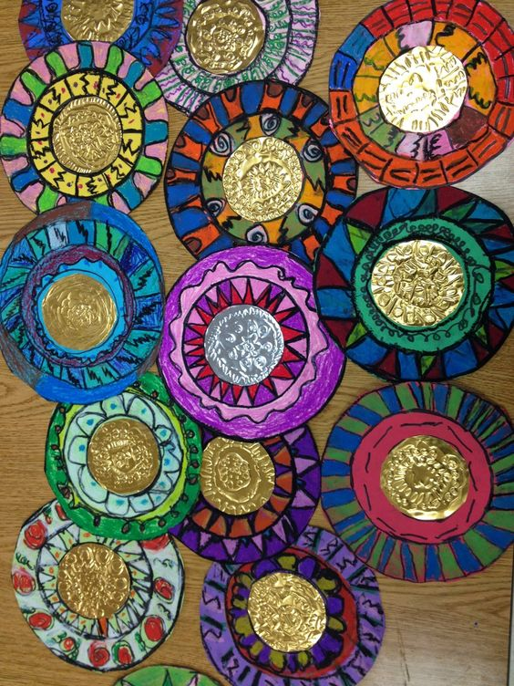

There are lots of ideas on Pinterest

You could use:
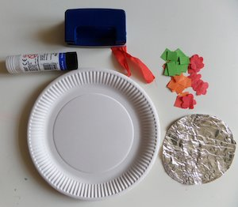
- Paper plate
- Pieces of tin foil
- Coloured paper
- Felt tipped pens
- Short length of ribbon for hanging
- Glue stick
- Stapler to attach ribbon

