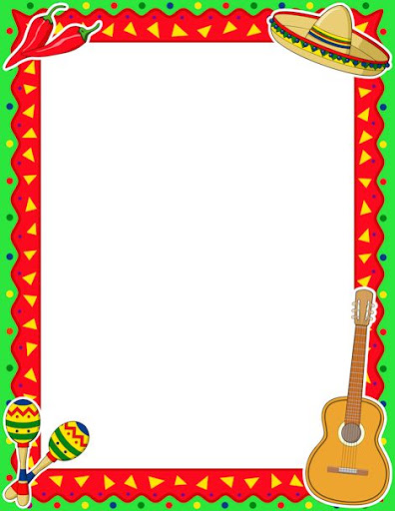

Write a section in your book on: **Life as a Maya Child**

<http://www.livescience.com/7958-maya-murals-give-rare-view-everyday-life.html> -Rare murals giving glimpse into everyday life of the Maya; <http://mayas.mrdonn.org/children.html> - Life as a Maya child.

Famous Five:

This is an instruction manual on packing for an expedition.

Can you write an account of The Famous Five’s crossing of a Mexico river on the hunt for a lost Mayan temple?

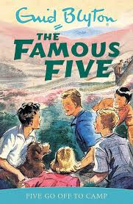

Make your own Nature Reserve.

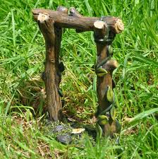

Draw and label a diagram of it at the start and then again each week.

Listen to some Mexican Music:

A YouTube video of Mariachi music  
[Jarabe Tapatio, (Mexican hat dancing)](https://youtu.be/-5q8T5b5GYQ?t=36) - YouTube clip  
[Folk dancing at the Guelaguetza Festival](https://www.youtube.com/watch?v=Xjhu65drsoE) - YouTube clip  
[The Guelaguetza festival in Oaxaca, Mexico](https://vimeo.com/46936958) from vimeo.com  
[Mixtec dance, Guelaguetza Oaxaca](https://www.youtube.com/watch?v=W3-jtiaYQc0) - YouTube clip

**And……..30 minutes of Maths Whizz a day!**

Colour, cut out and stick in order “The Journey of a River” sheet.

**Investigating Rivers**-research the answers to these questions on UK rivers. Compare the longest Mexican river to UK river-which is longest? What is the difference?

Spanish-how many of the words on the Spanish picture dictionary can you learn?

What are the longest rivers of Mexico?

Can you list them in order of length?

Pollination: 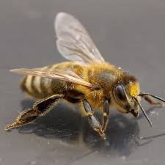

Read and complete the sheet. Carry out a survey in your garden. Which plants are the bees visiting?

Draw the flowers they like best.

Why do you think they like these flowers best?

**Mayan gods and Beliefs: watch the powerpoint.**

**Can you design your own Mayan god?** 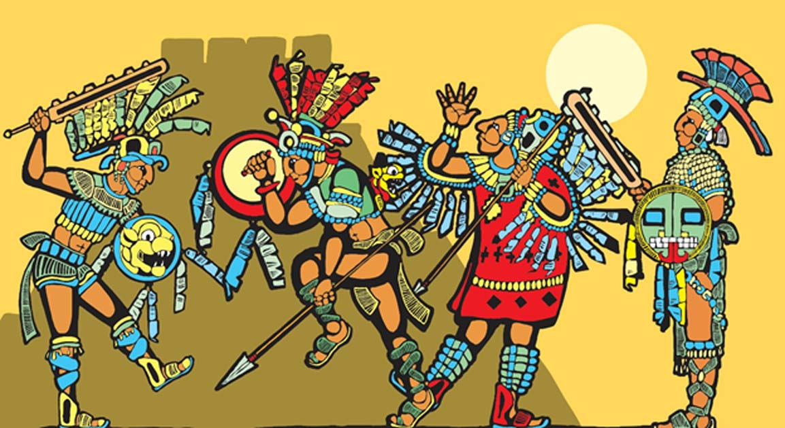

Collect as many shades of blue, purple, white, silver and black paper to tear and stick to make a water themed collage.

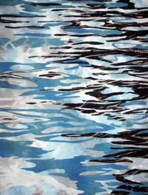

**Week 4**

You have 6 river poems to read this week.

Which do you like best?

Why?

Can you write your own river poem?