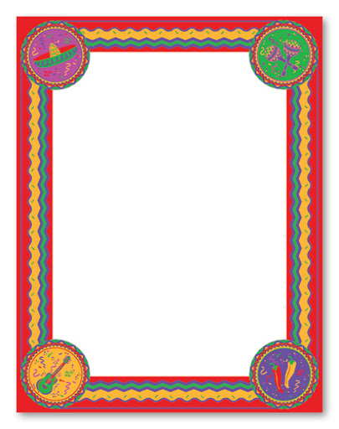

Can you make your own butterfly feeder? 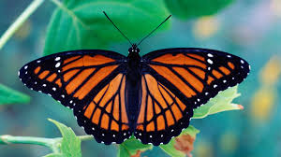

Science:

Can you win the Life-cycles game? There is a pollination chart to complete.

Learn about cacti and how they are adapted to survive in the desert.

Can you research and write about the animals and plants of the Mexican deserts and include illustrations?

Week 5

Geography:

What and where are the deserts of Mexico?

Can you label the main deserts of the world?

What is a desert?

What are the temperatures like in each Mexican desert?

What would you need to take with you to survive in a desert?

**Read about Chicken Itza: Imagine you are exploring this site.**

**Write an account in the first person of what you could see, what the atmosphere was like and what you could hear around you. Remember to use: personification, metaphors and similes, powerful verbs and great punctuation.**

**Art: Read about Frida Kahlo.**

**Research her work.**

**Can you paint or draw a copy of one of Frida’s works? Why have you chosen this piece?**

**And…30 minutes of Maths Whizz a day!**

**Can you sort the foods sheet into alphabetical order?**

**Which words can you spell?**

**You have some problem solving sheets to work on. Have fun!**

Tell Me Why - read this sheet. Can you create your own Tell Me Why about a subject you would like to know more about?

Can you make your own cactus? You could use paper or sew a cactus using felt. If you really went to town you could make a desert scene.

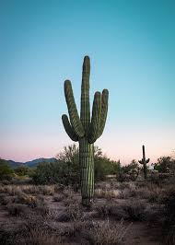

The three poems this week are about the moon.

Can you find any poems about deserts?

You have some shape poem layouts to write your own desert poem. You could use a desert animal or plant or the moving sands or the relentless sun as your inspiration.

:

**History:**

**Read about the Maya and The Aztecs. What are the similarities and the differences between the foods these people ate?**

**Can you make the hot chocolate? What does it taste like with chilli powder in it?**

