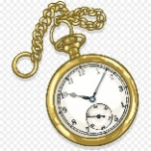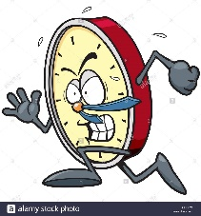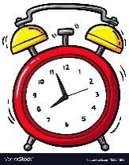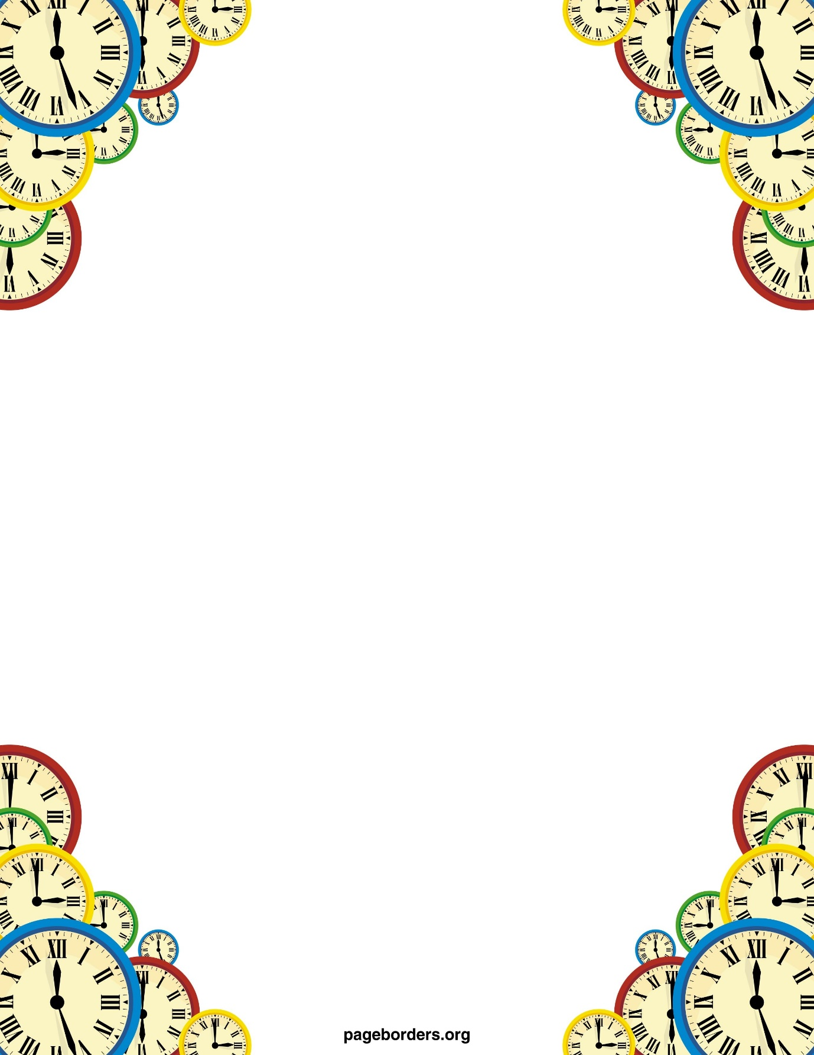

Poems:

Poems about time this week.

Which poem is your favourite?

List any new vocabulary from these poems.

What do these words mean?

Can you write your own poem about time?

Maths:

Watch:

<https://www.bbc.co.uk/bitesize/topics/zhk82hv/articles/zcmdwxs>

Can you complete the quiz?

Time sheets to complete.

World time zones: can you answer the questions on time zones around the world?

Clock problems: can you solve the problems?

History:

Watch the clip from The British Museum:

<https://www.youtube.com/watch?v=ggvRga_JqXw>

Can you find some facts on Big Ben?

Story starter: Time for secrets.

Can you carry on the story?

Can you include any of the vocabulary from the poems?

Comprehension:

In The Museum Of Past Centuries.

Read the poem.

How did it make you feel?

Can you answer the questions?

Proverbs about time?

What is a proverb?

Can you match the proverb with the meaning?

Art-look at the Salvador Dali surrealist painting on clocks.

Why do you think the clocks are melting?

Can you collect pictures of clocks and make a collage?

Maybe you could draw your own clock to include in your work.

<https://www.youtube.com/watch?v=uJk4Qw4fvp0>

Tell the time in Spanish.

Watch and join in with the video.

Can you complete the matching activity sheet?

Science:

Can you make your own clock?

You have several suggestions.

Which one did you make?

Why did you choose this?

Did it work?