**Topic –**

Once you have made your minibeast hotel, can you draw it and label which minibeasts you have made habitats for? There is an example attached.

**English**

Daily phonics or Grammar activities will be uploaded onto Tapestry – please check Tapestry everyday for these.

On BBC Bitesize they have daily English lesson, please complete these at home.

Daily reading – remember to use Oxford Owl for access to hundreds of free books.

Do you know what instructions are? When do you follow instructions? Do you ever make Lego? Follow a recipe? These are instructions.

This week, after you have made your minibeast hotel, can you write a list of instructions about how you made your minibeast hotel?

There are some examples online.

**Willows**

**Home Learning   
Week 6**

**Down on the Ground**

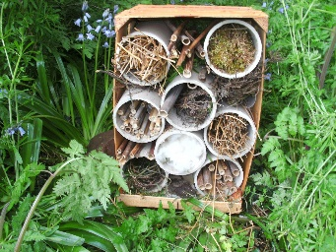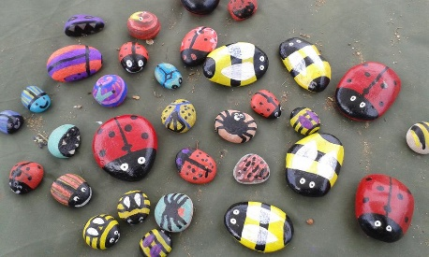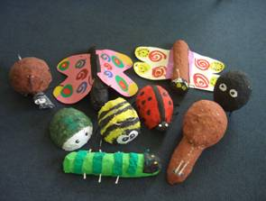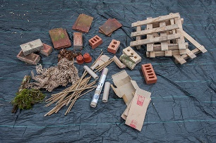

**Topic - weather**

The weather affects what we do, would you go swimming in the sea in Winter? Would you wear t-shirt and shorts in the snow?

Can you complete the attached how weather affects what we do sheet?

**Computing**

**Espresso Coding –** use school log in

**Art/DT – Pebble minibeast**

Can you paint your own pebble minibeast? You need to go hunting for an oval pebble, then be creative. You could paint it to make it look like a bumblebee, or a ladybird. You could paint a dragonfly and add your own wings.

**P.E.** Use Joe Wicks live PE session.

<https://www.youtube.com/channel/UCAxW1XT0iEJo0TYlRfn6rYQ>

**Topic** – **minibeast hotel**

Do you now what a minibeast hotel is?

Can you research what a minibeast hotel is?

The RSPB have some great information about minibeast hotels, including instructions to make it and a list of resources you will need. This is a video about how to make a minibeast hotel <https://www.youtube.com/watch?v=OexxoXo9uFk>

**Maths**

Year 1 and 2

Daily Maths Whizz sessions – please aim for 30 minutes a day

Reception

Daily counting and number writing to 20

Year 1 and 2

BBC Bitesize

On the BBC Bitesize they have daily maths lesson

<https://www.bbc.co.uk/bitesize/dailylessons>

Please use this. There are daily videos, activities and worksheets you can access. This will take the children through the maths curriculum.

Receptions

There are daily videos and activities here for Reception, but you are also welcome to access the Year 1 videos.

<https://www.bbc.co.uk/bitesize/subjects/zr99cqt>